


LFA Competition
Open Call
Putting Community at the Core of Copthall Pavilion

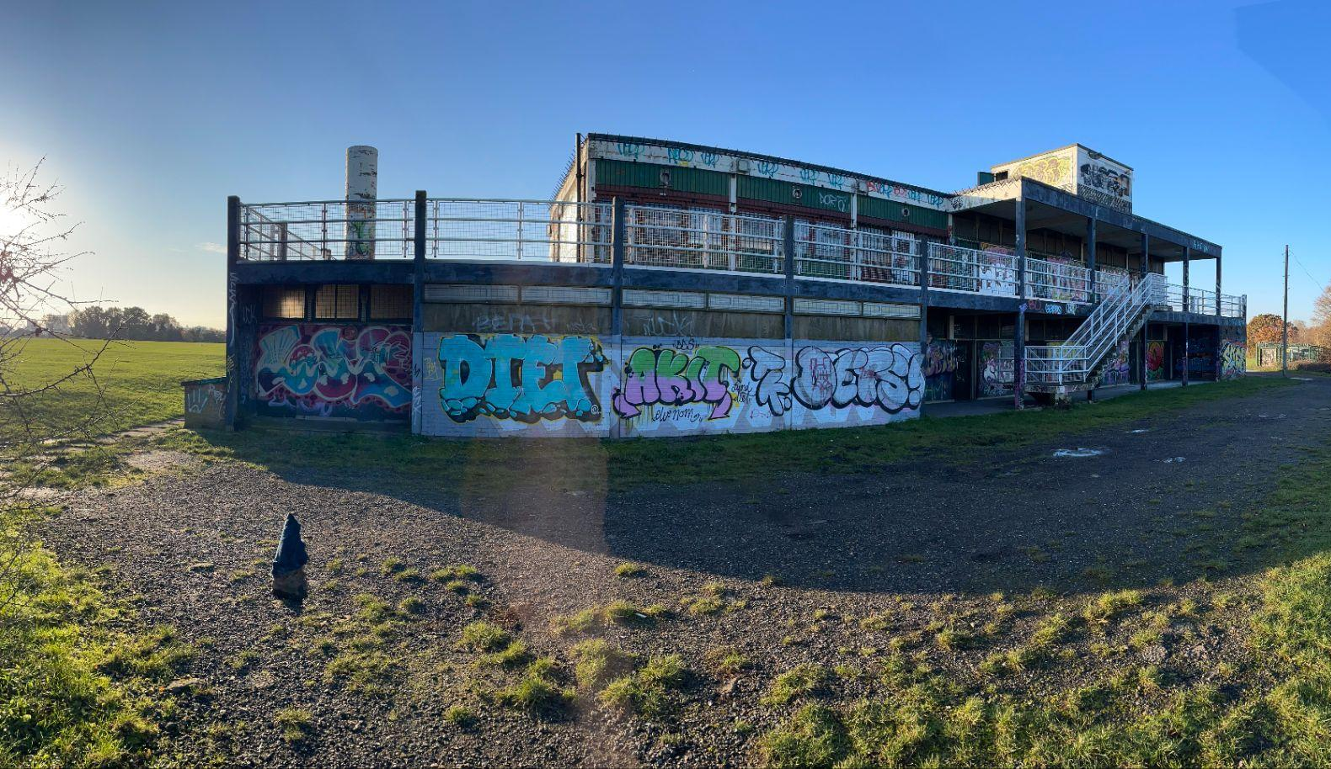

1
The commission

London Borough of Barnet has partnered with the London Festival of Architecture (LFA) to animate a two-storey sports pavilion located in Copthall Playing Fields, near Hendon’s Sunny Hill Park. The winning intervention will successfully reimagine the pavilion’s dilapidated exterior, creating an asset that better serves its local community and the disparate groups that use it and will help to inform long-term decisions about the future of this asset.

LFA are inviting teams of architects, designers and artists, as well as local community groups and individuals, to propose interventions that could transform Copthall Pavilion’s harsh exterior and create a welcoming environment for all of the parties that use it - including local sports teams, individuals, and young people for whom the pavilion acts as a social space.

A winning team will be confirmed in March and awarded circa £35,000 + VAT to develop a fully costed, feasible design alongside community engagement plan that can be delivered in June, to coincide with the London Festival of Architecture’s 20th anniversary. Consultation activity will focus around the 8th and 9th of June 2024, when the site will be animated by a series of designer- and community-led events to form a highlight of Barnet’s Destination programme for LFA2024.
2
The Site

The Pavilion sits in Copthall (originally known as Copt Hall) Playing Fields next to Hendon’s Sunny Hill Park, an area of Special Archaeological Significance with Roman roots. The area’s unique aviation history as the historical home of London Aerodrome continues to make its mark on the area with the RAF Museum.

With Mill Hill to the North, Hendon Central to the South, and Finchley to the East, the playing fields are an important sports and leisure space that is free and accessible to the public in an area with a prominent sporting legacy including Saracens Rugby Club, just a stone’s throw away.

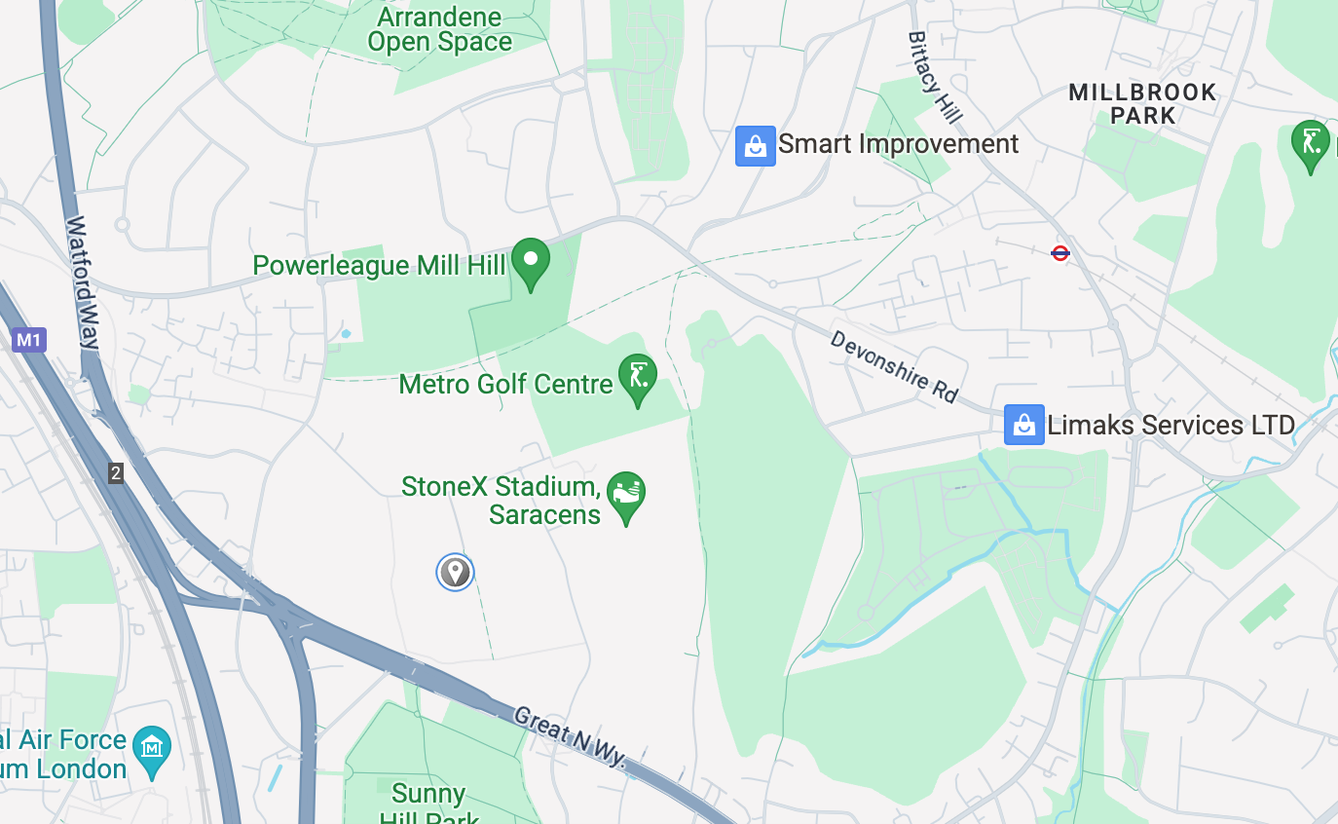

The pavilion

Sports pavilions have been a stalwart of parks and playing fields since the 17th century, when the facilities were introduced for croquet, bowls, cricket, and other sports. Many of the structures which continue to be used and loved transcend function, with a unique character that acts as a relic of social history.

The Copthall Pavilion is a 60s structure that has fallen into a state of disrepair, suffering from vandalism and some structural problems. Despite its condition, the pavilion continues to be used by local sports teams as a changing facility and is a popular site for solo footballers to practise their shots against its weakening walls. It is also a social hub for young people who shelter from the wind behind its graffitied façade.

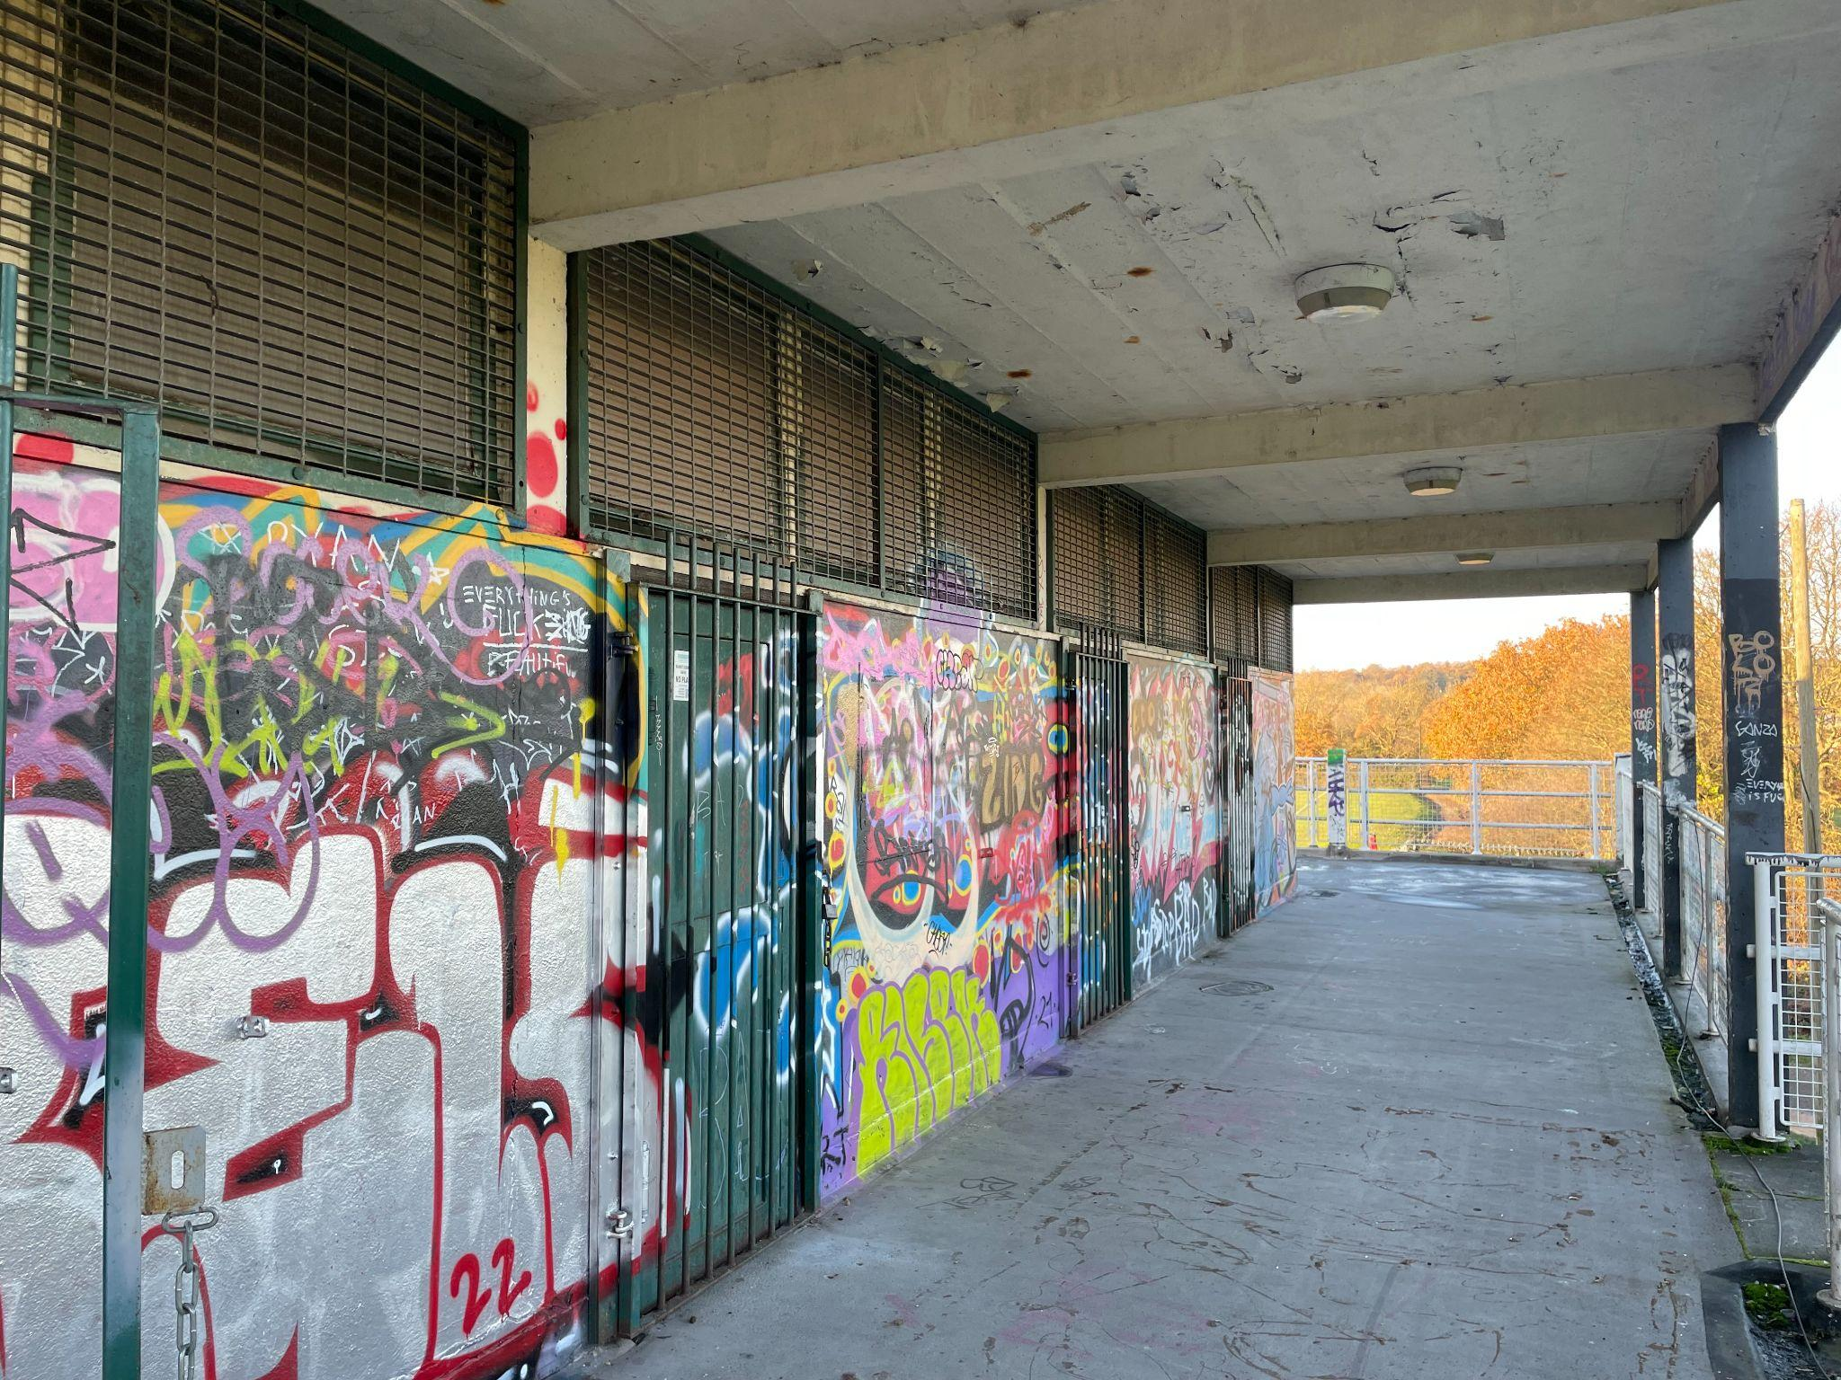

3
Design and engagement requirements

The aim of the physical interventions and community engagement sessions are to draw positive attention to Copthall Pavilion as an important community asset, engendering local pride and to transform the harsh exterior which is visible from the playing fields and nearby sports centre. Barnet Council is also keen to gain an understanding through this project of how the space is used by diverse groups and how it could go on to be permanently developed into a useful community asset.

The key objectives of the project are to deliver:
- Physical improvements to the pavilion exterior that may include painting, planting or recladding
- Design improvements that appeal to local sports teams who use the pavilion as a changing space
- Interventions that are welcoming to families, children and individuals who use the space for play, but also for the young people for whom the Playing Fields a social space
- Design solutions that are in place for a minimum of one month and that test long-term possibilities of how the pavilion may better serve the local community
- Community programming with engagement activities delivered across the weekend of 8th/9th June
- A presentation of findings from community engagement that the team will present to Barnet Council

Physical interventions

Pavilion exterior interventions may include, but are by no means limited to:
- Recladding or repainting
- Public art e.g. murals
- Green walls
- Active play walls
- Lighting interventions
- Additions to the surrounding public realm e.g. bike racks, seating, planting, outdoor exercise equipment

The winning proposal should lean into the ways in which the pavilion is currently used, while making the space more inviting.

Engagement deliverables

The winning team is required to engage with the local community and key stakeholders identified by the council during the delivery of the project. Programming should invite individuals to share memories and testimonials about their previous experience with the site, gather an understanding of the needs and wants of the community in regard to the space.

The appointed team will be required to present their findings and reflections on how the pavilion can be reimagined for a future generation at the end of the project.

Engagement activities may include, but are not limited to:
- Exhibitions
- Practical/co-design workshops
- Formal consultation sessions
- Sporting games/events
- Community film screenings

The minimum engagement requirements are:
- Consultation sessions delivered across the weekend of 8th/9th June
- Delivery of findings report to Barnet Council by 31 July

4
Community engaged practice

Barnet’s local community is central to this project, and the improvements to Copthall Pavilion should provide a space for community organisations, groups and residents to feel welcome and a sense of ownership.

We encourage proposals to take a socially engaged approach and to deliver positive outcomes for local residents and local communities. The winning team will be invited to meet with community organisations in the area surrounding Copthall Playing Fields including representatives from Copthall Community Sports Group to develop their concepts.

The design proposals need to foster participation and respond to the local context, but we are particularly looking for submissions that propose a collaborative approach with local organisations including schools, groups or residents. Your proposal could be in partnership with existing groups or outline how this collaboration would realistically work in the months leading up to the Festival, including reward and recognition.

The LFA and London Borough of Barnet will provide links with community organisations and groups, as well as guidance on collaborative and equal working relationships, to the winning design team on appointment.

If you are a local stakeholder who would love to get involved, please email info@londonfestivalofarchitecture.org with a short biography of yourself and your work, as well as any relevant experience and your reasons for wanting to be a part of this project.

5
Budget

The total budget available for delivery of this project is circa £35,000 + VAT. This needs to include all costs associated with implementation: materials, any necessary licences/planning fees, maintenance, other capital costs and contingency. Minimum contingency within the budget should be 10%, although we recommend allocating 15% contingency.

The budget allocation for the different project components (design fee, engagement activities, physical installation) is not prescribed. You are invited to suggest how you would plan to split the budget in your proposal.

The winning team will be responsible for leading on the engagement, fabrication and installation of the design, whilst working closely with internal teams from LFA and London Borough of Barnet to facilitate the installation.

The winning team will be expected to undertake the following tasks:
- To develop a fully costed, feasible design that can be installed for or during June 2024
- Programme and deliver public engagement and consultation during the design development and delivery phase of the project, with a focus on the weekend of 8 and 9 June 2024
- Project management of the installation of the intervention(s)
- Produce a brief summary of findings from the consultation for Barnet Council

6
Eligibility

The competition is open to architects, designers, engineers, artists, urbanists, community social enterprises and creative organisations. The selected project team must
include a named architect, engineer or designer but we are looking for cross disciplinary teams that reflect this diverse expertise and experience.

The judges encourage entries from, or collaborations with local groups or those who are underrepresented in decision making about public space. The focus is on inclusivity, cross-collaboration and practices with innovative approach. The judges will give priority to submissions from local designers or those who have chosen to collaborate with local groups.

For this reason, we are encouraging local designers, artists or community groups with bright ideas about how to reimagine the Copthall pavilion, but who may not have specific architecture, engineering or design experience to reach out to us directly with expressions of interest.

If you are an individual or community group looking to get involved, please email info@londonfestivalofarchitecture.org with a short biography of yourself and your work, as well as any relevant experience you have and your reasons for wanting to be a part of this project. The LFA will consider these expressions of interest with the possibility of linking their local knowledge with existing design teams.

7
Submissions requirements

This competition has a single-stage submission.

We ask that applicants prepare a PDF (max. 10 pages) for submission that includes:

- Brief biographies of the project team with headshots
- A 200-word description about your practice or background along with any relevant technical expertise acquired through previous experience
- A selection of relevant previous work, including images
- An overview on why you are interested in being involved in the project and how you would work to deliver your proposal if selected. Please include:
  - Thoughts about your vision including any initial written reactions you may have to the brief
  - An indicative budget demonstrating how you would allocate build and engagement costs (to be developed, if successful)
  - Thoughts you have about conducting engagement exercises
  - Optional: concept sketches of possible outcomes

Please note that if your practice is not VAT registered, you will need to consider this when preparing your budget.

Submission information

For any questions about the competition or submission process, please email info@londonfestivalofarchitecture.org.

8
Deadline and submission details

- Deadline for submission is midday, Monday 11 March. Submissions received after this time will not be considered
- For competition enquiries please contact: info@londonfestivalofarchitecture.org
- Please use this link to send your expression of interest in a PDF format
- The PDF should be no more than 5MB and 10 A4 pages (both portrait or landscape are acceptable)
- You will receive an email from Zealous confirming the receipt of your submission

9
Schedule outline

- Open Call Launch - Thursday 15 February
- Online Q&A for interest applicants REGISTER HERE - Monday 26 February
- Deadline for expressions of interest - Monday 11 March
- Judging session - w/c 18 March
- Winner notified - 29th March
- Design and programme development - April/May
- Delivery - June 2024, focus weekend 8 & 9 June
- Summary of consultation - delivered by 31 July

10
Judging panel

The judging panel will include:

- Richard Young, Greenspaces Development Officer, Barnet Council
- Chris Donkin, Strategic Lead for Active Environments, London Sport
- Francesca Murialdo, Director of Programmes in Interior Architecture and Design, Middlesex University
- Tom Kendall, Director, Wayward Plants
- Catherine Staniland, Director, NLA (Chair)

With more judges to be announced shortly.

11
Judging criteria

This is a one-stage competition, open to two categories. Each category will be scored on the criteria below:

- Team profile 40% - Does the team have skilled professionals for delivering the proposal in line with eligibility outlined in the Open Call? Does the team have a diverse set of skills and experience? Are the previous work experiences and/or their work methodologies and wider design aspirations relevant to the competition?
- Initial vision 30% - Does the proposal's initial vision suggest a visually engaging, thought-provoking design that would transform the exterior in a creative and innovative way? Does it inspire behavioural change?
- Approach to public engagement and collaboration 30% - Is the proposal strongly collaborative, participatory and socially engaged, with ambition to work with groups underrepresented in decisions about public? Does the proposal demonstrate a strong understanding and commitment to diversity and inclusion?
Individual expressions of interest
Expressions of interest that are shared with the LFA by email will be carefully considered with regards to their community connections, experience working on similar community-led projects, and any other reasons applicants provide. The LFA will then work with the winning design proposal to consider best methods of collaboration.

Individuals can expect to hear back from the LFA team following the appointment of the winning design team in late March.

12
Further information

- Submissions will be judged on originality, demonstration of creativity, relevance to the brief as well as feasibility and how the proposal works in the context of the site.
- To process entries to this competition we will share your application and any associated personal data provided on the application with our jury and competition partners.
- All applicants will be notified of the outcome of their application, but due to the volume of submissions we may not be able to provide feedback to entrants individually
- Applicants may not be assisted in any way in their submission by members of the judging panel, the client body, organisers, members of their family, close business associates or employees
- The ownership of Copyright of the design will be in accordance with the Copyright, Designs and Patents Act 1988, that is Copyright rests with the author of the submitted design
- All designs remain the intellectual property of the designer
- Please bear in mind the project requires a fast turn around and may have peak moments when your practice will need to dedicate sufficient staff to deliver the project on time, to budget and to the high standard expected by all stakeholders
- If your practice/collaboration is appointed to deliver the project it will need to have the following insurance: Employers Liability, Professional Indemnity, Public Liability
- Significant efforts are made by all stakeholders of the project to ensure wide media coverage
- LFA reserves the right to use images from the submissions for promotional purposes in press, social media and publications. All endeavours will be made to ensure accurate accreditation

13
Contact

To submit your entry please head to Zealous.

For general enquiries please contact: info@londonfestivalofarchitecture.org

14
Disclaimer

The competition organisers are not liable for lost, misdirected, or late entries. Decisions of the jury represent their professional judgments and all decisions are final. While it is the intent to construct the winning scheme, the organisers reserve the right to not proceed with construction for any reason. Material submitted by you shall be your sole responsibility, shall not infringe or violate the rights of any other party or violate any laws, contribute to or encourage infringing or otherwise unlawful conduct, or otherwise be obscene, objectionable, or in poor taste. By submitting such material, you are representing that you are the owner of such material and/or have all necessary rights, licences, and authorization to distribute it.

15
Commissioning organisations



The London Festival of Architecture (LFA) is a month-long celebration of architecture and city-making, taking place every June across London. Now in it’s 20th year, LFA’s mission is to open up discussions around architecture, test new ideas and promote emerging talent. LFA brings together the public and built environment professionals for the whole month of June and seeks to inspire and engage our audience with a programme that showcases London as a global architecture hub. LFA is run by NLA, London’s built environment community.
www.londonfestivalofarchitecture.org
Twitter: @LFArchitecture
Instagram: @LondonFestivalofArchitecture



From Edgware to Cricklewood, and Finchley to Hampstead Garden Suburb, Barnet is known for being one of London’s largest and greenest boroughs. Historically, Barnet has been a borough that has supported commerce with 30 town centres which play different roles in the wider community.

“We’re delighted that the borough of Barnet will be a returning destination for the London Festival of Architecture in 2024. The Festival is a great opportunity to showcase our architectural heritage in the borough, which defines our unique character.”

“It’s a chance to work with local people and community groups to amplify the amazing cultural offerings and talent we already have here and attract artists and other cultural contributors to come here.”

“Cultivating culture and arts in our borough is more than just an investment in creativity – it’s an investment in our communities and the local economy.”

Cllr Ammar Naqvi, Cabinet Member for Culture, Leisure, Arts and Sports at Barnet Council

https://www.barnet.gov.uk/

Copt Hall refers to the buildings that would have stood on the site of the playing fields during the Tudor in the 15th and 16th centuries.

