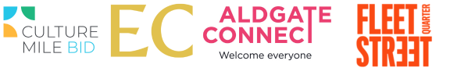

Navigating Change
Reimagining the Square Mile

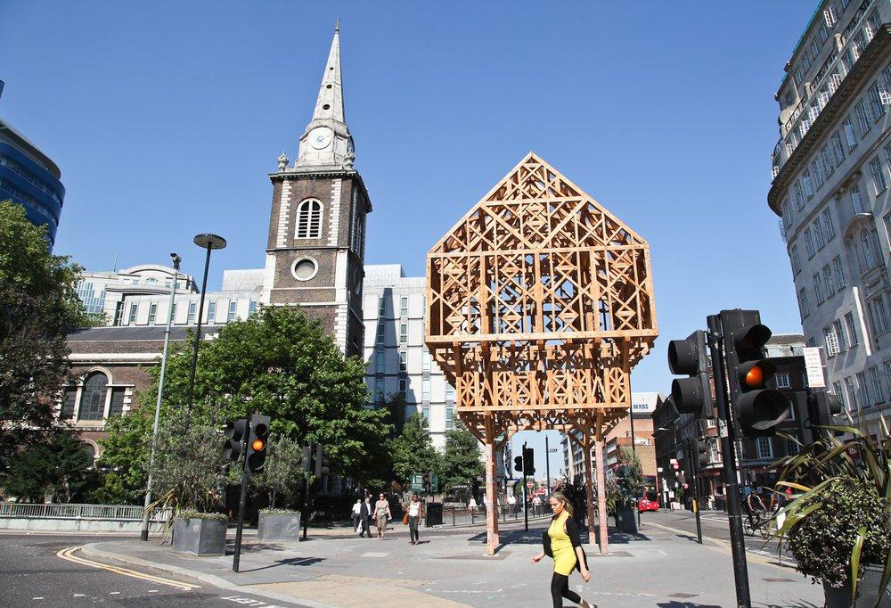
LFA 2012. Paleys upon Pilers by Studio Weave

1
The commission

The City’s Business Improvement Districts, Aldgate Connect, Culture Mile, EC BID, and Fleet Street Quarter, are collaborating with the London Festival of Architecture for LFA2024 to commission a trail of creative architectural interventions across the City of London, inviting architects, designers, and artists to propose playful public realm interventions that envision a more welcoming and sustainable city, with outcomes potentially including outdoor auditoria, urban furniture, public art, planting, and wayfinding elements for Summer 2024.

Over the last six years the City Business Improvement Districts (BIDs) have been working with the London Festival of Architecture (LFA) to deliver a range of projects to enhance the area and bring innovative design solutions to an ever-changing city. This year each of these districts have come together to commission a trail of distinct but connected architectural interventions which stretch across the City, that communicate a narrative about the changing Square Mile and evoke its rich histories. Each intervention in the trail will respond to its local context, test out alternative scenarios for the public realm and provide the backdrop for cultural programming for Summer 2024.

This is a unique opportunity to gain an exciting commission and showcase your creativity and ability to produce a stunning trail of architectural interventions on a global stage.

Following the competition process, one or more winning teams will be revealed in January 2024 and will work with Aldgate Connect, Culture Mile, EC BID, Fleet Street Quarter and the London Festival of Architecture in delivering a fully costed, feasible design.

2
Context

The City of London (the City) has been a centre for settlement, trade, commerce and ceremony since the Roman period, producing a unique environment of exceptional richness and significance. Now the financial district of London, the City is home to over 22,000 businesses and 587,000 workers. Also known as the Square Mile due to it’s 1.12 sq m footprint, the City has been at the forefront of innovation and change for centuries. The growth in the City’s business and cultural links has seen the emergence of five new Business Improvement Districts since 2015 who collaborate on delivering an enhanced public realm environment supporting new leisure and cultural activity.

LFA 2024
2024 marks 20 years of the London Festival of Architecture, a month-long celebration of architecture and city-making that takes place every June across London. #LFAat20 will be a moment of celebration, and a chance to reflect on the impact of the Festival over last two decades, as well as the wider industry and city. It will also be a moment to reset, to explore how the Festival, industry, and all Londoners can shape a more equitable, accessible and sustainable city – a London by, and for, all Londoners.
LFA has a long history of trialling initiatives in the public realm which have been the catalyst for meaningful change for the city. This June, we’re asking our Festival partners and community to reimagine public spaces by putting people back at the centre of the city. We want public spaces across London to be temporarily reimagined to capture the public’s imagination and inform longer term meaningful changes.

3
Design Guidance

The key objectives of the project are to deliver a series of architectural installations which:
- Test out new scenarios for how the public realm in the City of London can better serve its people and planet
- Respond to their hyperlocal context
- Create an exciting narrative which drives the public to visit each unique site along the trail
- Are playful and creative and will capture public imagination and appeal to a wide audience
- Provide spaces for cultural activations which invite people to participate in conversation about the future of the City
- Respond to the LFA theme of reimagine

Possible outcomes include:

- Outdoor auditoriums or other performance space
- Provision of urban furniture e.g. seating
- Public art e.g murals
- Inclusion of sound installations as a different medium to improve the immediate surroundings and encourage dwell time
- wayfinding elements, signposting
- Planting, enhancing biodiversity

Further Guidance:

- Though each of the installations will be unique, together the trail must form a cohesive piece using shared design language
- Wayfinding between each of the City locations could also be considered as part of this project
- Designs must be practical and realistic, whilst responding to the project objectives
- Any final design will be robust enough to withstand all weather conditions
- Designs will need require minimal maintenance
- Interventions should not block fire hydrants, fire exits, utility covers, street signage etc.
- The project will be in situ for a minimum of 1 month and you should consider the longevity and appearance of your design accordingly, to ensure that no or minimal maintenance is required during this period. Subject to durability, the project may be able to be in place for longer or moved to a different location for an extended period.
- The City BIDs are committed to commissioning public realm interventions that are accessible to the broadest possible audience. Concepts should be developed with an understanding of how public space is interpreted and used by different groups, and how proposed interventions could contribute to the happiness, safety, and wellbeing of the wide-ranging individuals and groups using these spaces.

4
Working with a client

The winning team will work with Aldgate Connect, Culture Mile, EC BID and Fleet Street Quarter as their main client to develop their final designs. You will be expected to work with each of the BIDs to identify their objectives and then produce a worked-up design for the chosen sites which consider how people of a variety of ages, abilities and needs could interact with your design. The LFA will also approve these to ensure they are deliverable, and work with the client team to ensure the relevant approvals are secured.

Fortnightly design review meetings will be held in the London Centre for the designers and client team to come together to review design, costs and timeline from February 2024.

The winning team will be responsible for leading on the fabrication and installation of the design, whilst working closely with internal teams to facilitate the installation.

The winning team will be expected to undertake the following tasks:
- To develop a fully costed, feasible design that can be installed in May 2024
- Project management of the installation of winning design

As part of this project, the clients will be working on programming to activate the architectural trail and you may be invited to contribute to events as part of the festival’s programme, for example a designer’s tour or workshop.

5
The City BIDs

For this architectural trail, site(s) in each of the four Business Improvement Districts detailed below will be chosen (in discussion with the designer, client team and landowners) to house the installations. Below you will find more detailed information about each of the key BID areas and their key priorities for the public realm.
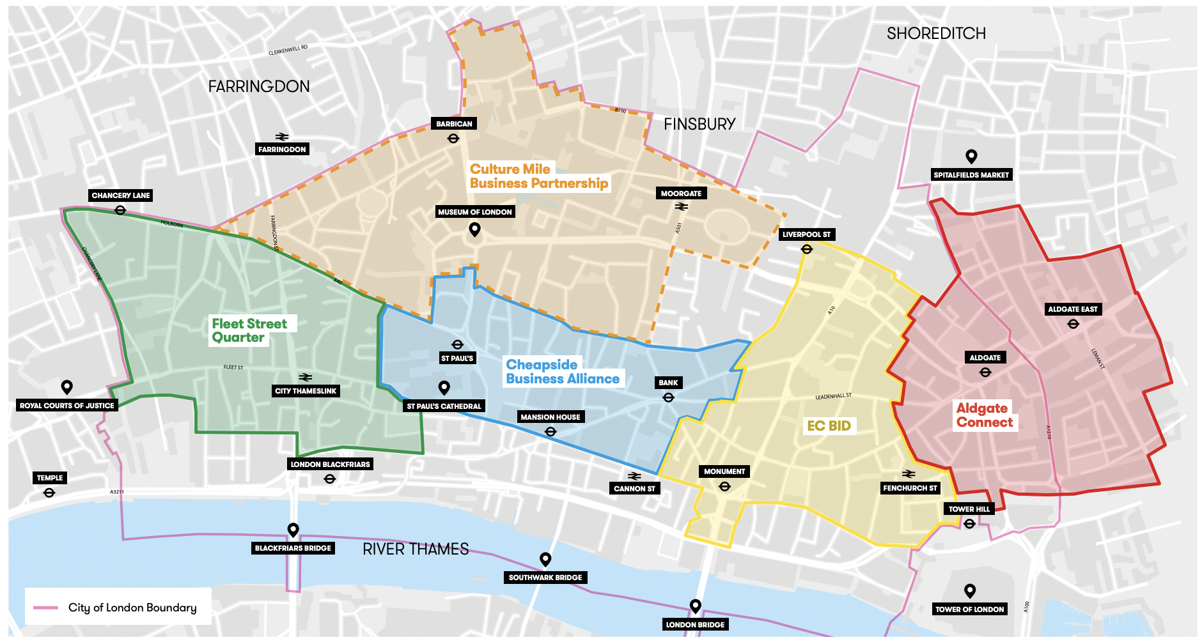
Map of the City of London marking the boundaries of the Business Improvement Districts

Aldgate Connect

Aldgate straddles two boroughs – The City of London and Tower Hamlets. In July of 2022, the Aldgate Public Realm Vision & Strategy was developed in partnership with Aldgate Connect BID, local landowners and tenants, City of London, Tower Hamlets, and other core cultural and educational institutions. The document reviewed Aldgate’s public realm and highlighted projects and development opportunities in the coming years. It also led to the creation of a clear public realm mission statement: “Establish Aldgate in its iconic location as a well-connected, cohesive community known for its intricate network of green spaces, and celebration of its unique artistic and cultural heritage”. Please see section 15 of this brief to access the full strategy.

The area around Vine Street has been highlighted as a key priority for Aldgate, providing a fantastic site to showcase Aldgate’s history and DNA. In 2023 part of the old Roman Wall along Vine Street was made visible to the public through a new, free, museum-quality display and café created by Urbanest. With a cohesive public realm upgrade, Vine Street can become the pioneer site to respond to the ‘walkable city’ concept from the London Plan. Aldgate Connect want to use this competition to reimagine the public realm and explore creative ways that public spaces can be activated, potentially laying the foundations for longer term improvements.

Culture Mile Business Partnership

The Culture Mile BID was established in April 2023 following a successful ballot, beginning its first five- year term. The Culture Mile BID area is experiencing significant transformation, through the arrival of the Elizabeth Line, the Smithfield redevelopment, the Barbican renewal and other key developments and public realm schemes. This change can present challenges as well as opportunities: how do people navigate the area? How does the Barbican, as a significant cultural anchor in the area, interact with surroundings? What role does the historical context of the Smithfield market area play in the future of public space and how people use it? How do people interact with the heavy traffic on London Wall, and interact with the hidden green spaces in the backstreets?

Culture Mile’s current focus is on understanding how it can activate existing spaces, as well as work with stakeholders and developers to leverage increased public amenity, seating and greenery, offering breakout space, increasing dwell time and improving wellbeing. The integration of cultural activation into the public realm is also vital. Culture Mile are interested in exploring through this competition how underutilised spaces in the area around Moorgate Station and London Wall could be reimagined and activated through an architectural intervention.

Eastern Cluster

The Eastern City is an extraordinary commercial hub, home to some of the City’s most iconic architecture and of course, the tall building cluster, which presents both challenges and opportunities from a public realm point of view. From elevated public spaces, to hidden courtyards and winding through routes, the area has been 2000 years in the making, combining historic gems with world-class contemporary buildings.

Through the reimagining of public space with creative temporary installations, they want to use this competition as an opportunity to test out some of the principles set out in an emerging Public Realm strategy, as a precursor to longer term improvements and use of space. What is the role for public space in such a unique location, how does a patchwork of different spaces come together to create a seamless destination, and how can it evolve to serve and attract a variety of users? EC wants this competition to help us answer these questions.

Fleet Street Quarter

Fleet Street Quarter (FSQ) represents 43 hectares of the Western Side of the City of London. The BID has recently launched a new public realm strategy (see section 15). This chimes with the extensive development pipeline the area is seeing. Three million sq ft with an anticipated increase in office worker footfall of 25,000 over the next 5 years. The BID are continuing to activate spaces around the footprint for cultural use, encouraging a greater sense of community and increased dwell time in public spaces. Sustainability and placemaking sits at the heart of what FSQ do.
FSQ has been home to a number of literary legends including Samuel Pepys, Charles Dickens, Dr Johnson and Shakespeare! The development pipeline will also see a new Justice quarter, the Salisbury Square scheme boasting 18 new law courts and a new City of London Police headquarters. The law and the media have featured throughout the history of this area. Oracy, democracy and thought have been central to its evolution. Through this competition FSQ are seeking to explore and expand the concept of public auditoria and how they can bring communities together.

6
Sustainability

Sustainability is at the heart of this brief and the future of the City. The City’s Climate Action Strategy aims to achieve net zero of the Square Mile by 2040 making the City of London Corporation the first UK governing body to have a fully funded net zero commitment that covers all emissions.

Although the architecture trail is designed to be temporarily in situ, we encourage and support our designers and partners to plan for the afterlife of these projects which go on to be re-homed or recycled.

The City BIDs are interested in seeing approaches that will explore principles of the circular economy. Either by thinking about the longevity of the design and materials, flexibility of purpose and plans for disassembly (and reassembly). You can use salvaged materials or seek in-kind materials sponsorship to reduce expenses.

7
Budget

The total budget available for delivery of this project is £100,000 + VAT. This needs to include all costs associated with implementation; materials, any necessary licenses/planning fees, maintenance for up to 1 month, other capital costs and contingency. Minimum contingency within the budget should be 10%, although we recommend allocating 15% contingency.

The budget outlined includes a 12.5% designer fee (£12,500) to cover on-going design fees and other costs required to deliver the concept. If your practice is not VAT registered, you will need to consider this when preparing your budget.

Each of the sites will have a portion of the budget allocated to them. The scale of the installation will need to match the budget for each of the sites. The split of the budget will be shared with the winners in order to develop their proposals.

8
Submissions requirements

This is a one stage competition.

We ask that applicants prepare a PDF (max. 10 pages) for submission that includes:
- Brief biographies of all the project team with headshots
- A 200-word description about your practice along with any relevant technical expertise acquired through previous experience
- A selection of relevant previous work, including images.
- A short reflection of max. 400 words on why you are interested in being involved in the project and how you would work to deliver your proposal if selected. Please include some thoughts about your vision including any initial written reactions you may have to the brief.
- No more than one concept sketch to illustrate your initial vision in response to the brief.

Please note that we are not asking to see fully developed designs as part of this submission, but rather hear your response to the brief and initial ideas for how you would approach the project, if selected. The BIDs are particularly interested in hearing how you approach the materiality of the design and ensure that the design would be sustainable.

These submissions will be reviewed by the client body and the external judging panel and a winning proposal will be selected to be delivered in 2024.

Submission information
For any questions about the competition or submission process, please email: info@londonfestivalofarchitecture.org

9
Eligibility

The competition is open to architects, landscape architects, designers and artists. We welcome collaborations; however, the project team must include a qualified architect or landscape architect.

The commission provides an exciting opportunity for artists and creatives to be involved in reimagining and activating the City of London. The City BIDs are not looking for fully developed designs as part of this submission, but rather initial ideas and examples of similar projects. Following appointment, the chosen individual / team can work with local stakeholders to develop ideas into more detailed design concepts.

The judges encourage entries from, or collaborations with groups who are underrepresented in architecture and design. We are inviting larger architecture or design practices to team up with smaller studios or other creatives for this project. If you are interested in forming a team or collaboration for this submission but don’t already have the connections you need, please get in touch.

10
Deadline and submission details

- Deadline for first submission is Midday, 9 January 2023. Submissions received after time this will not be considered.
- For competition enquires please contact: info@londonfestivalofarchitecture.org
- To send your expression of interest in a PDF format go here.
- The PDF should be no more than 5MB and 10 A4 pages (both portrait or landscape are acceptable)

Submission information

We are using zealous.co to administrate our application process. To submit your expression of interest for this competition, you will need to set up a free login on zealous which will enable you to begin your submission as a Draft and save it as you go. You can find information about how to submit via zealous here.

If you have any feedback on using this platform, please do let us know so we can help improve the experience of entering LFA competitions. For any questions about the competition or submission process, please email: info@londonfestivalofarchitecture.org

11
Schedule outline

- Submissions open: 5 December 2023
- Online drop-in session for interested applicants: 13 December 12.30pm – 1.30pm. Register here.
- Submissions closed: 9 January 2024, midday
- Judging: w/c 15 January 2024
- Winner notified: 26 January 2024
- Project delivered: late May 2024

12
Judging panel

All submissions will be reviewed by the client body and judged by an external panel.

The panel will include:

Chair - Benjamin O’Connor, Director, NLA
Clarisse Tavin, Group Manager Major Programmes and Projects, City of London
Eddie Blake, Director, Studio Weave
Harriet Browning, Associate, Civic Engineers
Paolo Mendoza, Landscaping and Urban Design Consultant, Arcadis
Hannah Penwarden, Student Representative, London Metropolitan University

With more judges to be announced shortly

13
Judging criteria

- Practice/Team profile - 30% Does the team have skilled professionals for delivering the proposal in line with eligibility outlined in the Open Call? Does the team have a diverse set of skills and experience? Are the previous work experiences and/or their work methodologies and wider design aspirations relevant to the competition?
- Initial vision - 30%: Does the proposal's initial written reflection to the brief suggest innovation, surprise and creativity? Does it explore a new and original way to use and engage with the area?
- Feasibility - 20%: Does it propose an approach which seems feasible and deliverable within the budget and set timeframe?
- Approach to Environment and sustainability - 20%: Does the proposal consider the impact of their work on the environment e.g. materials used, methods of construction? Can the built element of the project be re-used or re-cycled after de-installation?

14
Further information

- Submissions will be judged on originality, demonstration of creativity, relevance to the brief as well as feasibility and how the proposal works in the context of the site.
- To process entries to this competition we will share your application and any associated personal data provided on the application with our jury and competition partners.
- All applicants will be notified of the outcome of their application, but due to the volume of submissions we may not be able to provide feedback to entrants individually.
- Applicants may not be assisted in any way in their submission by members of the judging panel, the client body, organisers, members of their family, close business associates or employees.
- The ownership of Copyright of the design will be in accordance with the Copyright, Designs and Patents Act 1988, that is Copyright rests with the author of the submitted design.
- All designs remain the intellectual property of the designer however the winning design will itself when built will be the property of the BIDs.
- Please bear in mind the project requires a fast turn around and may have peak moments when your practice will need to dedicate sufficient staff to deliver the project on time, to budget and to the high standard expected by all stakeholders.
- If your practice/collaboration is appointed to deliver the project it will need to have the following insurance: Employers Liability, Professional Indemnity, Public Liability.
- Significant efforts are made by all stakeholders of the project to ensure wide media coverage.
- LFA reserve the right to use images from the submissions for promotional purposes in press, social media and publications. All endeavours will be made to ensure accurate accreditation.

15
Useful links

Fleet Street Quarter Public Realm Strategy
https://3f49a686-4687-452f-b5fe-6cdeda7b6498.usrfiles.com/ugd/3f49a6_b57136b8b0444699b33143a7748e536d.pdf

Aldgate Public Realm Vision and Strategy
https://aldgateconnect.london/wp-content/uploads/2022/09/Aldgate_Public-Realm-Strategy_Report-FINAL_LR.pdf

The City Wall at Vine Street
https://citywallvinestreet.org/

London Festival of Architecture:
www.londonfestivalofarchitecture.org

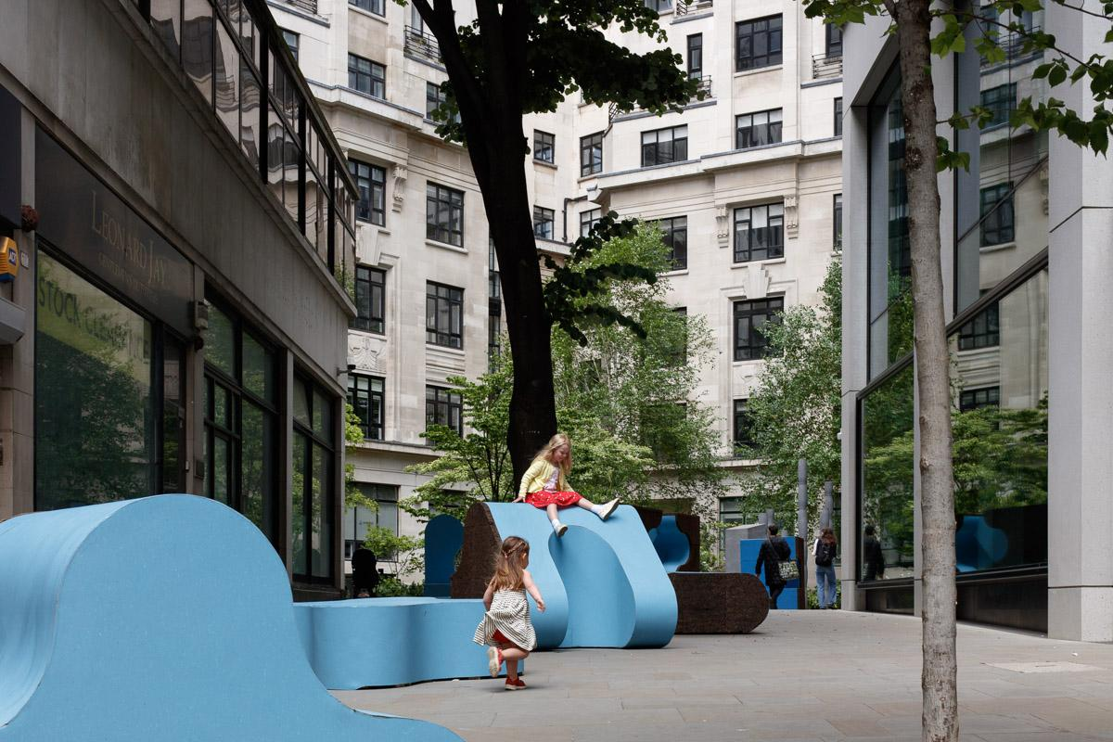
LFA 2023: Urban Playground by McCloy + Muchemwa for EC BID © Luke O’Donnovan

Previous LFA installations in the City of London
Urban Playground (EC BID) 2023
www.londonfestivalofarchitecture.org/lfa-competition/urban-playground/

Seats At The Table (Culture Mile) 2023
www.londonfestivalofarchitecture.org/lfa-competition/co-designing-equity-in-the-public-realm/

On Tenterground (Aldgate) 2023
https://www.londonfestivalofarchitecture.org/lfa-competition/on-tenterground/

The Herbalist’s Press (Fleet Street Quarter) 2023
https://www.londonfestivalofarchitecture.org/lfa-competition/the-herbalists-press-a-garden-by-fleet-street-quarter/

Common Ground (Cheapside) 2023
https://www.londonfestivalofarchitecture.org/lfa-competition/common-ground/

Mobile Arboretum (Cheapside & Aldgate) 2022
https://www.londonfestivalofarchitecture.org/lfa-competition/mobile-arboretum/

City Benches competitions 2021, 2020, 2019, 2018
2021 https://www.londonfestivalofarchitecture.org/lfa-competition/city-benches/
2020 https://www.londonfestivalofarchitecture.org/lfa-competition/city-benches-3/
2019 https://www.londonfestivalofarchitecture.org/lfa-competition/city-benches-2/
2018 https://www.londonfestivalofarchitecture.org/lfa-competition/city-benches-4/

St Paul’s Plinth 2018
https://www.londonfestivalofarchitecture.org/lfa-competition/st-pauls-gateway/

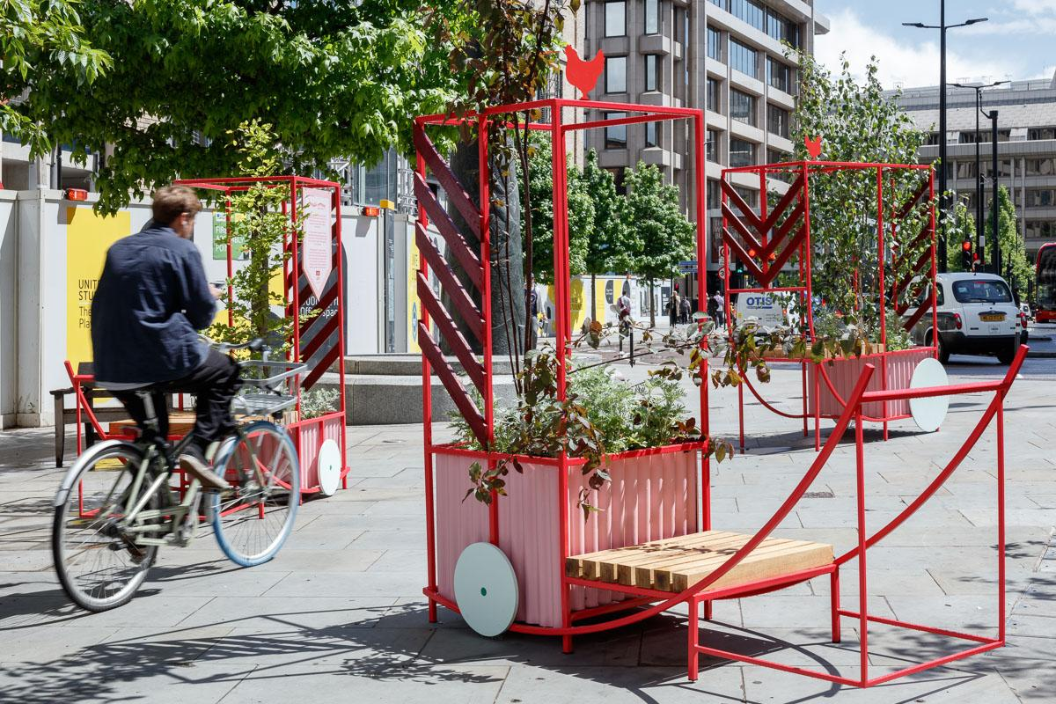
LFA 2022: The Mobile Arboretum for Aldgate Connect © Luke O’Donnovan

16
Contact

To submit your entry please go here.

For general enquires please contact: info@londonfestivalofarchitecture.org

17
Disclaimer

The competition organisers are not liable for lost, misdirected, or late entries. Decisions of the jury represent their professional judgments and all decisions are final. While it is the intent to construct the winning scheme, the organisers reserve the right to not proceed with construction for any reason. Material submitted by you shall be your sole responsibility, shall not infringe or violate the rights of any other party or violate any laws, contribute to or encourage infringing or otherwise unlawful conduct, or otherwise be obscene, objectionable, or in poor taste. By submitting such material, you are representing that you are the owner of such material and/or have all necessary rights, licenses, and authorization to distribute it.

18
Commissioning organisations

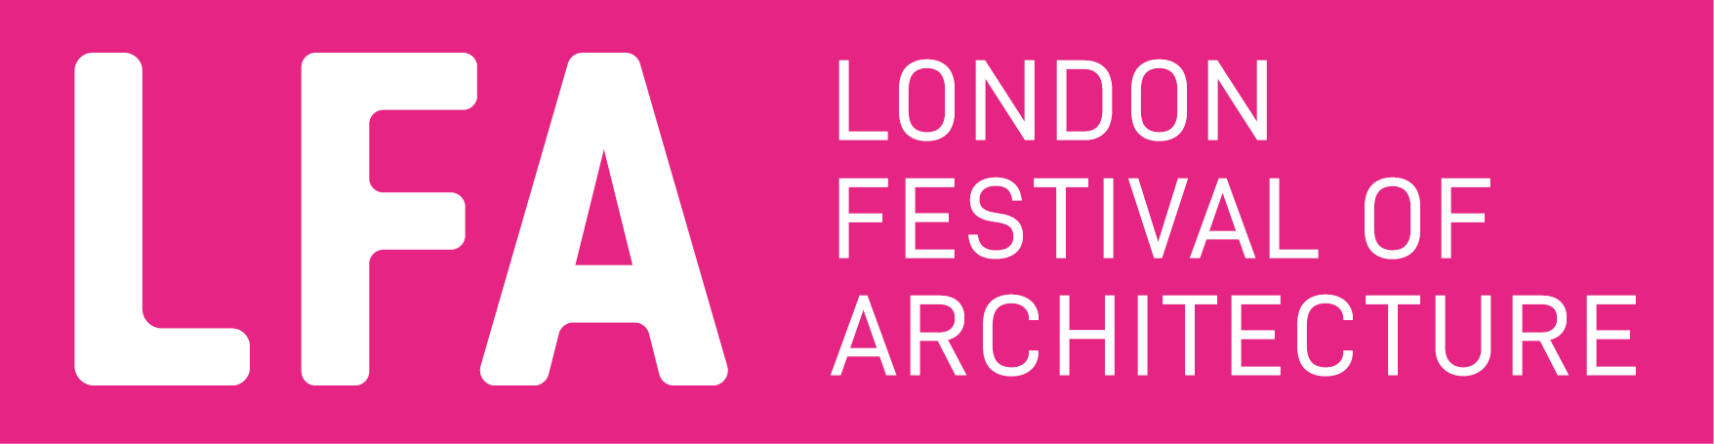

The London Festival of Architecture (LFA) is a month-long celebration of architecture and city-making, taking place every June across London. Now in it’s 20th year, LFA’s mission is to open up discussions around architecture, test new ideas and promote emerging talent. LFA brings together the public and built environment professionals for the whole month of June and seeks to inspire and engage our audience with a programme that showcases London as a global architecture hub. LFA is run by NLA, London’s built environment community.
www.londonfestivalofarchitecture.org
Twitter: @LFArchitecture
Instagram: @LondonFestivalofArchitecture

19
Glossary

A Business Improvement District (BID) is a business-led and business-funded body, created through a ballot process, to provide mutually-agreed improvements to a defined area in which a levy is charged on all business rate payers based on their rateable value. The BID is funded through this levy but can also utilise other public and private funding streams to develop projects that are intended to provide additional services or improvements to the local area over and above the services already provided by the local authority.
Circular Economy - A circular economy is as one where materials are retained in use at their highest value for as long as possible and are then reused or recycled, leaving a minimum of residual waste.

Terms that appear in pink can be found in the glossary at the end of this document.

