

Open Call
Find your way to Fitzrovia: Welcome to Warren Street

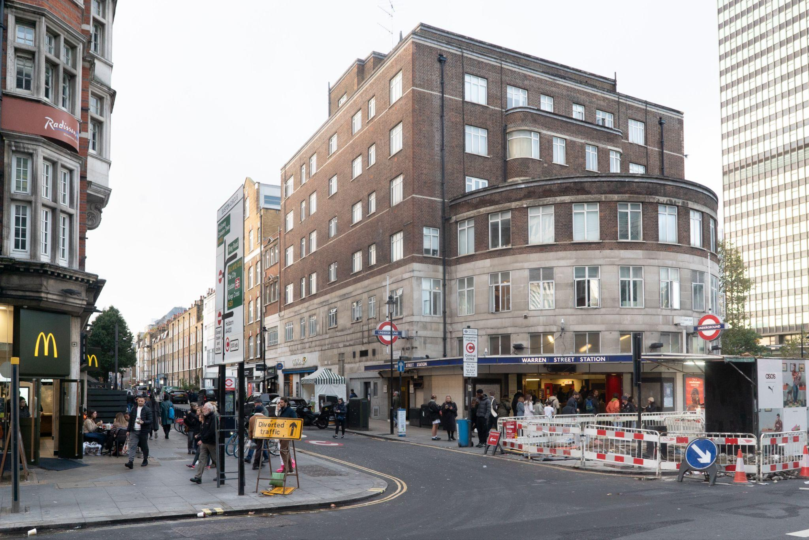
Entrance to Warren Street © Kes-tchaas Eccleston

1
The commission

Warren Street and Warren Street station marks one of the key gateways into the neighbourhood of Fitzrovia.

The Fitzrovia Partnership is inviting architects, designers and artists to develop and submit a creative design for temporary interventions that will improve the pedestrian environment outside Warren Street station, signpost to key destinations in the area and promote the use of less polluted and safe pathways. The Fitzrovia Partnership has commissioned London Festival of Architecture (LFA) to run the competition and find a creative team to design the project.

Fitzrovia is a neighbourhood situated between Marylebone, Bloomsbury and Soho, extending from Euston Road in the north, to Oxford Street in the south, and Tottenham Court Road in the east to Great Portland Street in the west. Fitzrovia will be a key LFA Destination for the London Festival of Architecture and will be working over the next four years on projects which will test and implement successful public realm schemes which can improve navigation and the overall experience around the whole Fitzrovia footprint.

This scheme would aim to improve the pedestrian environment around Warren Street, which currently suffers from street clutter, air pollution, waste and non-functional space. We are seeking proposals that will activate Warren Street station and invite people to enter Fitzrovia’s charming destination.

A winning team will be confirmed in March 2024 and awarded £37,000 + VAT (which includes a £4,625 design fee) to develop a fully costed, feasible design that can be delivered in June 2024 and be in situ for 1 month.

2
Context

As one of Fitzrovia’s key gateways, Warren Street has been identified in The Fitzrovia Partnership’s Placemaking Strategy (see section 13) as a priority location to improve. Being one of four gateways identified for improvement in the four year programme, the importance and legacy of this first build is to influence other solutions for the area and to act as an enabler for more permanent placemaking solutions across Fitzrovia.

Warren Street was originally named after the 18th-century naval officer Sir Peter Warren and it became known as the site of one of the most important second-hand car markets in London from the 1920s until well after the Second World War. Today, it is a low traffic road which leads to the leafy streets of Fitzrovia.

The Warren Street community is largely residential which has more recently welcomed independent cafés, restaurants and specialist retailers. Community groups such as Fitzrovia Youth in Action are actively involved in and around Warren Street, helping with maintaining the planting and acting as the community contact for the MUGA (Multi-Use Games Area) on nearby Whitfield Street. Local groups will be consulted on this project as part of The Fitzrovia Partnership’s community engagement framework.

Warren Street station is the gateway to Tottenham Court Road which over recent years has developed to become the ‘Home of Homeware’. Tottenham Court Road has more flagship homeware stores than any other street in the UK with Heal’s leading the way. This historic store started selling beds over 200 years ago at a location across the road from its current site.

Fitzrovia is known for its creativity which has prevailed throughout its history. Over the centuries, it has attracted artists, poets, writers, musicians, inventors and activists who have all left their mark. Characters such as John Constable, Augustus John, Alexander Pope, Karl Marx, Dylan Thomas, Virginia Wolfe and Nina Hammett have all called Fitzrovia home.

It has been a ‘first’ for many things - it was where My Fair Lady was written; where Charles Dickens was influenced for the novel ‘Oliver’; where Round the Horn was written; where abolitionist Equiano wrote ‘The Interesting Narrative’; where Lennon and Stalin visited; where Bob Dylan played his first gig out of the USA; where Reggie Kray took dance lessons; where the ‘Bloomsbury Set’ hung out; where the first Greek restaurant in London opened.

Today it continues to pave the way for new ideas and attracts creative influencers such as designers, design agencies, post-production agencies, film-makers, architects, built environment specialists, restaurateurs, mixologists and fashion houses. The bohemian vibe with the village feel and community spirit - made up of residents, employees, students and visitors - make it a unique place in central London. It is where global companies sit next to start ups, flagship stores sit next to independently run retail and hospitality venues, Michelin-starred restaurants sit next to cafes.

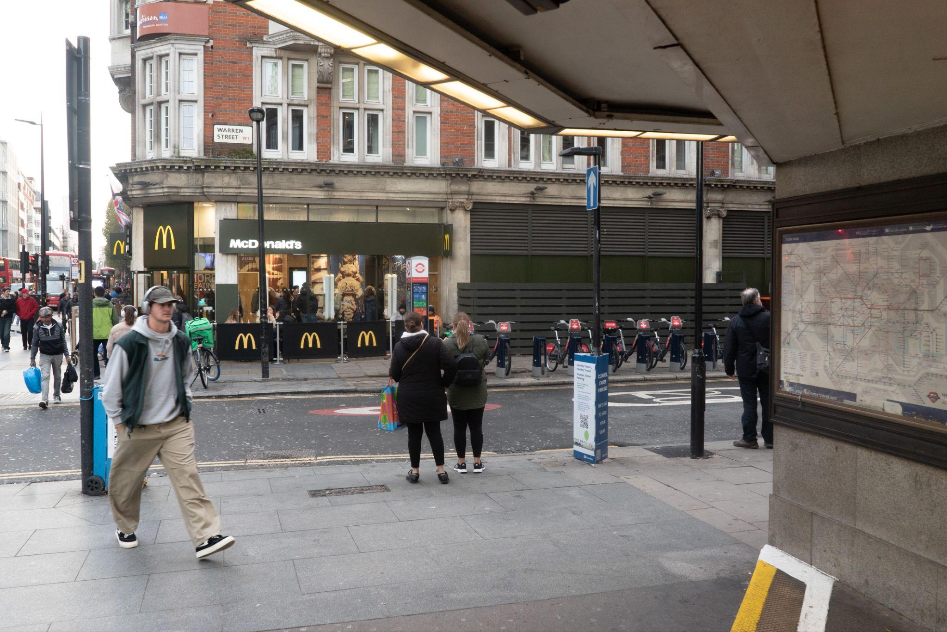
View from Warren Street © Kes-tchaas Eccleston
LFA2024

2024 marks 20 years of the London Festival of Architecture, a month-long celebration of architecture and city-making that takes place every June across London. #LFAat20 will be a moment of celebration, and a chance to reflect on the impact of the Festival over last two decades, as well as the wider industry and city. It will also be a moment to reset, to explore how the Festival, industry, and all Londoners can shape a more equitable, accessible and sustainable city – a London by, and for, all Londoners.

Responding to the LFA’s theme of ‘reimagine’, this brief is actively seeking innovative solutions for how Warren Street can become a more sustainable and navigable environment which puts people’s experience of the public realm first. Through this project LFA and The Fitzrovia Partnership are looking to test ways in which this space and the wider environment around Fitzrovia can be shaped for the future to better serve people and the planet.

3
Site

Warren Street is situated within the borough of Camden whose Transport strategy has four key overall objectives which are pertinent to this brief:

- To transform our streets and places to enable an increase in walking and cycling
- To reduce car ownership and use, and motor traffic levels in Camden
- To deliver a sustainable transport system and streets that are accessible and inclusive for all
- To reduce and mitigate the impact of transport- based emissions and noise in Camden
Several areas along the round have been identified as possible locations for where the intervention could be implemented, subject to landowner approval. However this does not prohibit ideas that span beyond these areas if they continue to meet the objectives of the brief and are mindful of the operations of the street.
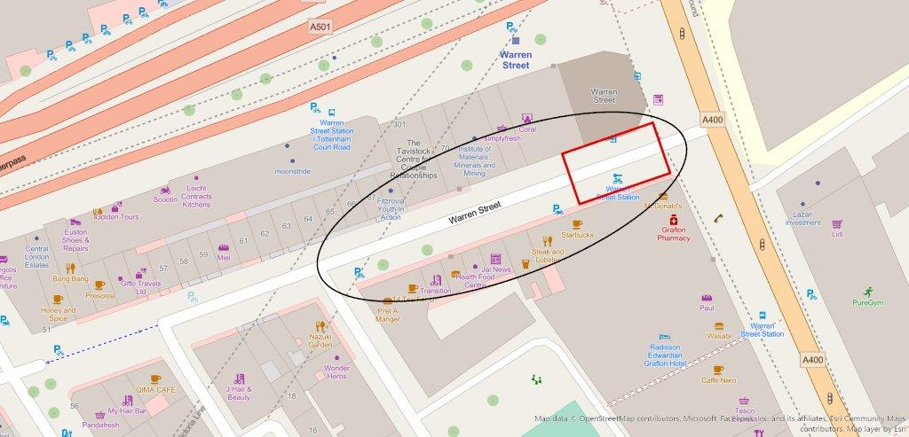Map of Warren Street: Site of focus in red, wider area indicated in black
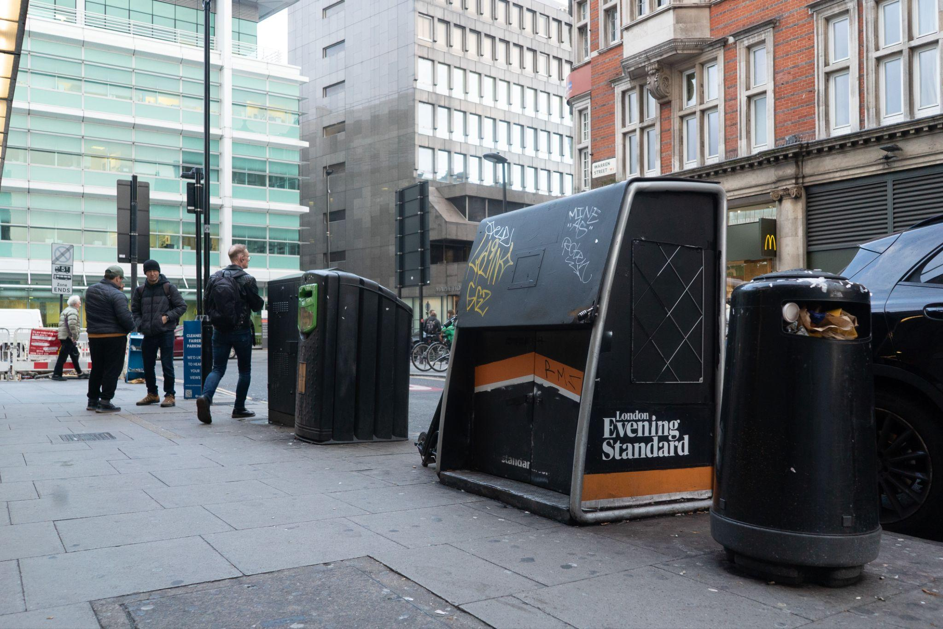
Street clutter outside Warren Street station © Kes-tchaas Eccleston

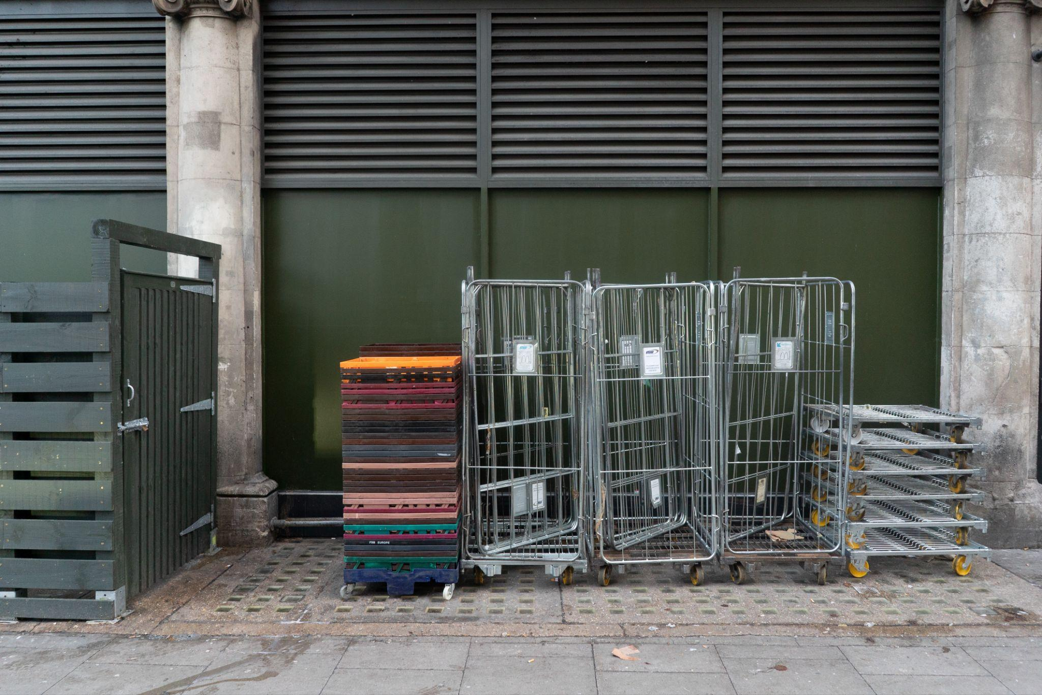
© Kes-tchaas Eccleston

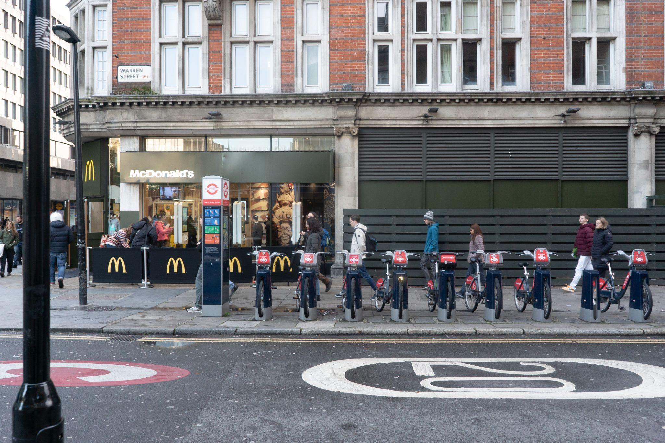
© Kes-tchaas Eccleston

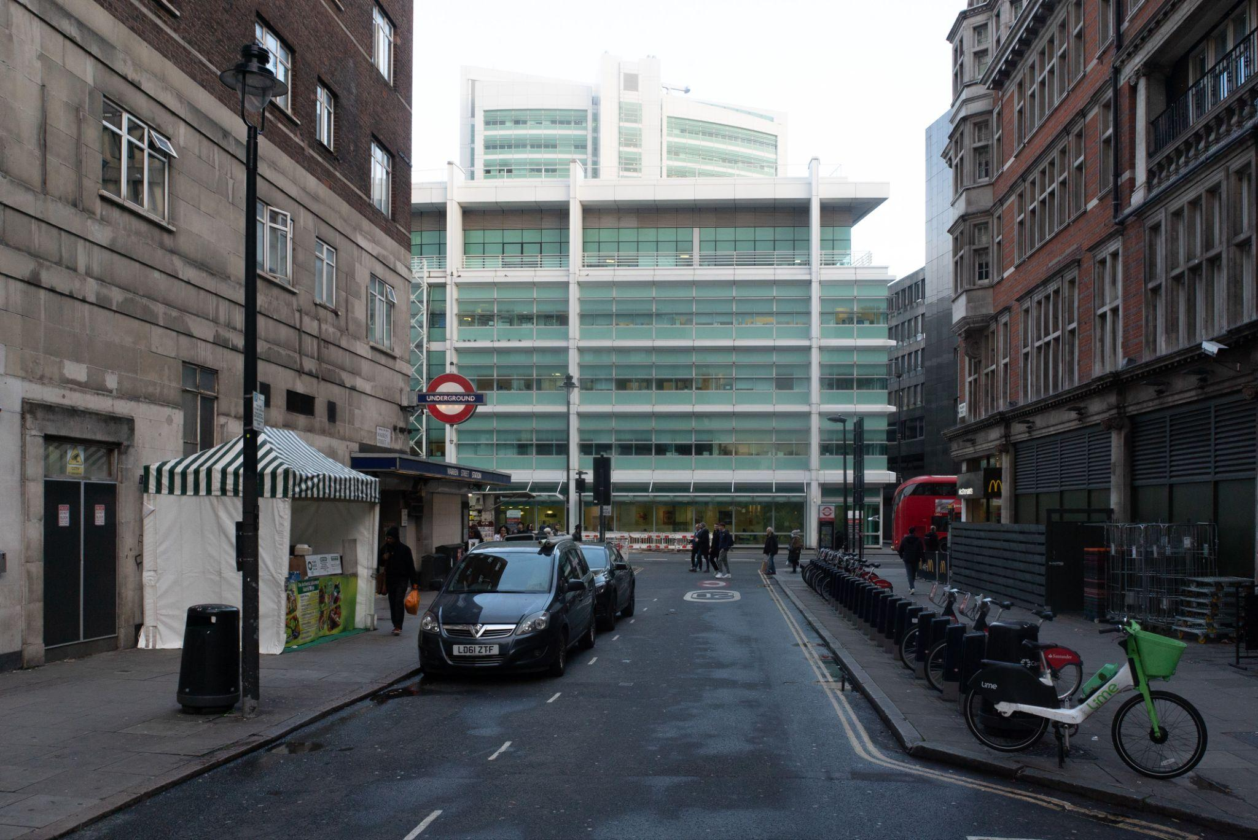
Entrance to Warren Street © Kes-tchaas Eccleston

4
Design Requirements

The key objectives of the project are to deliver a design that:
- Offers sustainable creative design solutions to the identified challenges in the area and re-imagines the experience of this entry point to the Fitzrovia district
- Celebrates the character and history of Fitzrovia – home, hospitality and creativity
- Incorporates wayfinding elements and signposting to the hospitality destinations found in Warren Street and the homeware destinations in Tottenham Court road
- Improves the pedestrian environment outside Warren Street station, currently suffering from:
  - Street clutter and waste
  - Unfunctional space and street furniture
  - Crime and anti-social behaviour
  - Waste
  - Vehicle congestion and air pollution

Possible outcomes include:

- Provision of urban furniture e.g. seating
- Public art e.g murals
- Lighting
- Inclusion of sound installations as a different medium to improve the immediate
surrounding and encourage dwell time
- Wayfinding elements, signposting
- Planting
- Canopy outside TfL station
- Activation of black frontages
- Catenary wires for suspending activations

Further Guidance:

- Designs must be sustainable, practical and realistic whilst responding to the project objectives – evidence should be given that it is buildable within the budget
- Any winning design will be robust enough to withstand all weather conditions
- Designs should also consider sustainability and require minimal maintenance
- Although the intervention is designed to be temporarily in situ, we encourage and support our designers and partners to plan for the afterlife of these projects which go on to be re-homed or recycled.
- Non-movable elements rather than movable elements are encouraged
- Interventions should not block fire hydrants, fire exits, utility covers, street signage, or any other emergency access
- The project will be in situ for a minimum of 1 months and you should consider the longevity and appearance of your design accordingly, to ensure that no or minimal maintenance is required during this period. Subject to durability, the project may be able to be in place for longer or moved to a different location for an extended period.

5
Budget

The total budget available for delivery of this project is circa £37,000 + VAT. This needs to include all costs associated with implementation; materials, any necessary licenses/planning fees, maintenance, other capital costs and contingency. Minimum contingency within the budget should be 10%, although we recommend allocating 15% contingency in your stage 2 proposal, if shortlisted.

The £37,000 budget outlined includes a maximum £4,625 designer fee to cover on-going design fees and other costs required to deliver the concept.

The winning team will be responsible for leading on the fabrication and installation of the design, whilst working closely with the Fitzrovia Partnership, Camden Council teams and other key stakeholders in the area to facilitate the installation.

The winning team will be expected to undertake the following tasks:
- To develop a fully costed, feasible design that can be installed by 31 May 2024
- Project management of the installation of winning design
- Be responsible for the de-installation of the design

6
Submissions requirements

This competition has a two stages submission.

This first stage submission should include:
- Full name and contact details including postal address, contact number and email of project lead.
- Brief biographies of all the project team.
- A 200-word description about your practice along with any relevant technical experience acquired through previous projects.
- A selection of relevant previous work, including images.
- A short paragraph of max. 300 words on why you are interested in being involved in the project and, how are you going to work with the local community to deliver your proposal if selected. Please include some thoughts about your vision including any initial written reactions you may have to the brief.
- No design work is required for the first stage.

At stage one we ask for a single PDF submission. Please note this should be no more than 10 pages and maximum 5MB.

These submissions will be shortlisted by the judging panel. Up to six shortlisted practices will then be invited to develop a design concept based on the information laid out in this open call and will be awarded an honorarium of £500 Inc. VAT each. The work required for the second phase of the project will be reflective of the honorarium sum.

At shortlisting, the second stage submission should include:
- Maximum 10-page PDF explaining your proposal to be shared with the jury for review, prior to interview.
- PowerPoint presentation for the purposes of judging.
- The submission should but is not limited to including hand or computer drawn 3D design visualisation, key construction details drawn to scale, with key dimensions noted, an outline all materials, budget*, maintenance plan and fabrication process.

*If your practice is not VAT registered, you will need to consider this when preparing your budget.

Submission information
For any questions about the competition or submission process, please email: info@londonfestivalofarchitecture.org

7
Eligibility

The competition is open to emerging architects, landscape architects, designers and artists. We welcome collaborations; however, the project team must include a qualified architect or landscape architect.

Applicants need to fulfil at least two of the following criteria to be eligible for this competition:
- being no more than seven years post graduate, from your most recent qualification
- being under 40
- set up your practice / collaboration in the past three years
- be part of a team within a larger practice that meets criteria 1 and 2
The judges encourage entries from, or collaborations with groups who are underrepresented in architecture and design.

8
Deadline and submission details

- Deadline for first submission is Midday, 10th January. Submissions received after time this will not be considered.
- For competition enquires please contact: info@londonfestivalofarchitecture.org
- To send your expression of interest in a PDF format go here.
- The PDF should be no more than 5MB and 10 A4 pages (both portrait or landscape are acceptable)
- You will receive an email confirming the receipt of your submission.

9
Schedule outline

- Submissions open: 8 December 2023
- Online Drop-In Q&A session for interested applicants: 19 December 12.30pm - 1.30pm. Link to register here
- Submissions closed: midday, 10 January 2024
- Round 1 Judging: w/c 15 January 2024
- Successful shortlisted teams notified: 19 January 2024
- Site visit with shortlisted teams: w/c 22 January 2024
- Round 2 submission deadline: 15th February 2024
- Final judging / interviews: w/c 19th February 2024
- Winner notified: 1 March 2024

10
Judging panel

The panel will include:

- Federico Ortiz, NLA, Head of Content (Chair)
- Lee Lyons, Chief Operating Officer, the Fitzrovia Partnership
- Lavinia Scaletti, Placeshaping Manager, Camden Council
- TfL Representative
- Edwin Heathcote, Architecture and Design Critic
- David Byrne, CEO,The Doctors Laboratory

With more judges to be announced shortly

11
Judging criteria

Round 1 Judging Criteria
- Practice/Team profile - 40% Does the team have skilled professionals for delivering the proposal in line with eligibility outlined in the Open Call? Does the team have a diverse set of skills and experience? Are the previous work experiences and/or their work methodologies and wider design aspirations relevant to the competition?
- Initial vision - 30%: Does the proposal's initial written reflection to the brief suggest innovation, surprise and creativity? Does it explore a new and original way to use and engage with the area?
- Feasibility - 30%: Does it propose an approach which seems feasible and deliverable within the budget and set timeframe?

Round 2 Judging Criteria
- Overall design – 25%
- Costs – 20%
- Approach to environment and sustainability – 15%
- Longevity and implications for maintenance – 15%
- Contextual design and public engagement – 15%

12
Further information

- Submissions will be judged on originality, demonstration of creativity, relevance to the brief as well as feasibility and how the proposal works in the context of the site.
- To process entries to this competition we will share your application and any associated personal data provided on the application with our jury and competition partners.
- All applicants will be notified of the outcome of their application, but due to the volume of submissions we may not be able to provide feedback to entrants individually.
- Applicants may not be assisted in any way in their submission by members of the judging panel, the client body, organisers, members of their family, close business associates or employees.
- The ownership of Copyright of the design will be in accordance with the Copyright, Designs and Patents Act 1988, that is Copyright rests with the author of the submitted design.
- All designs remain the intellectual property of the designer however the winning design will itself when built will be the property of The Fitzrovia Partnership.
- Please bear in mind the project requires a fast turn around and may have peak moments when your practice will need to dedicate sufficient staff to deliver the project on time, to budget and to the high standard expected by all stakeholders.
- If your practice/collaboration is appointed to deliver the project it will need to have the following insurance: Employers Liability, Professional Indemnity, Public Liability.
- Significant efforts are made by all stakeholders of the project to ensure wide media coverage.
- LFA reserve the right to use images from the submissions for promotional purposes in press, social media and publications. All endeavours will be made to ensure accurate accreditation.

13
Useful links

Fitzrovia Village Document, Public Realm and Placemaking Strategy
https://fitzroviapartnership.com/wp-content/uploads/2023/09/230816_Fitzrovia-Report.pdf

We Make Camden (the Council’s overall Vision)
wemakecamden.org.uk/wp-content/uploads/2022/04/We-Make-Camden-Vision.pdf

Camden Future High Streets
3f7a9208-8fa6-9bc7-eda7-ab8f5e1753eb (camden.gov.uk)

Diversity in the Public Realm
Design of the Strategy for Diversity in the Public Realm 2022 to 2023 (camden.gov.uk)

Camden Transport Strategy documents
Transport strategies and plans - Camden Council

Camden Biodiversity Strategy
cd72648d-b3e3-a512-dafc-dd02f15144c3 (camden.gov.uk)

Camden Clean Air Action Plan
Camden Clean Air Action Plan 20222026 Consultation Draft FINAL amended 2022.08.31.pdf (wearecamden.org)

Camden Green Spaces Strategies
Appendix 1 - Parks for Health Strategy Document.pdf (islington.gov.uk)

London Festival of Architecture:
www.londonfestivalofarchitecture.org

14
Contact

To submit your entry please go here.

For general enquires please contact: info@londonfestivalofarchitecture.org

15
Disclaimer

The competition organisers are not liable for lost, misdirected, or late entries. Decisions of the jury represent their professional judgments and all decisions are final. While it is the intent to construct the winning scheme, the organisers reserve the right to not proceed with construction for any reason. Material submitted by you shall be your sole responsibility, shall not infringe or violate the rights of any other party or violate any laws, contribute to or encourage infringing or otherwise unlawful conduct, or otherwise be obscene, objectionable, or in poor taste. By submitting such material, you are representing that you are the owner of such material and/or have all necessary rights, licenses, and authorization to distribute it.

16
Commissioning organisations



The London Festival of Architecture (LFA) is a month-long celebration of architecture and city-making, taking place every June across London. Now in it’s 20th year, LFA’s mission is to open up discussions around architecture, test new ideas and promote emerging talent. LFA brings together the public and built environment professionals for the whole month of June and seeks to inspire and engage our audience with a programme that showcases London as a global architecture hub. LFA is run by NLA, London’s built environment community.
www.londonfestivalofarchitecture.org
Twitter: @LFArchitecture
Instagram: @LondonFestivalofArchitecture



About The Fitzrovia Partnership
The Fitzrovia Partnership is a Business Improvement District (BID) representing more than 350 businesses across Fitzrovia. Its role is to bring together local businesses to provide added-value solutions and make a tangible difference to the area that benefits all stakeholders. Sustainability is at the heart of the organisation. This means leading campaigns on behalf of member businesses to reduce the environmental impacts of conducting business whilst improving economic and social sustainability. For 2024, The Partnership will be a Destination for the first time during the LFA month-long festival and Fitzrovia will host its first design competition to look at sustainable ways of providing solutions to public realm challenges.

fitzroviapartnership.com

