
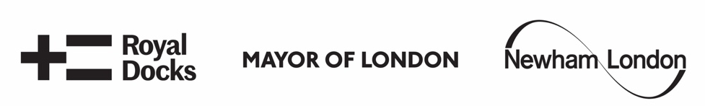
Open Call - Pews & Perches 2024
Fifth edition

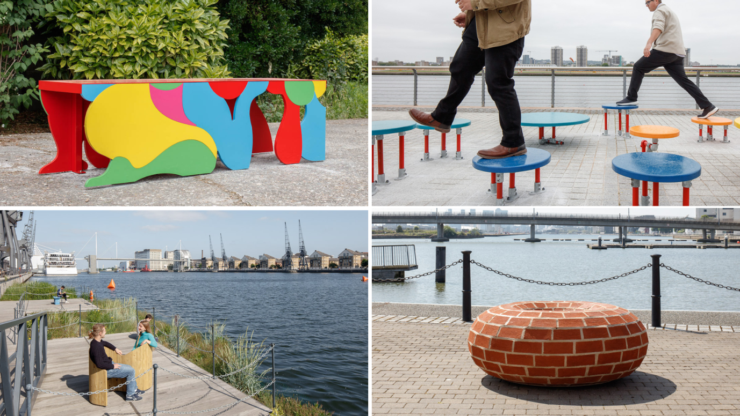

Winning benches from 2023 © Luke O'Donovan
- The commission

The London Festival of Architecture (LFA) and The Royal Docks Team (RDT) are inviting architecture and design students, recent graduates and emerging practitioners to
create one of several public benches, to be installed in the public realm of the Royal Docks in 2024.

Now in its fifth and final edition, this competition is seeking proposals that creatively embrace, explore and test circular economy principles in their design. Earlier this year, The Mayor of London set out his vision of London transitioning to a circular economy in the draft London Plan and published a primer for how to embed circular economy principles into design processes. When we look forward to the future of the industry, the importance of re-using and retaining materials is undeniable. Now is the moment to test out the ways we can achieve these strategies to best meet the needs of people and planet.

Designers can respond to this prompt in a variety of ways and push the boundaries of flexible or adaptive design. What are the past or future lives of a bench’s materials? Re-thinking ‘waste’ as ‘resource’ is central to this brief and we are interested in seeing creative ways to (re)use local materials in the bench design. You are also invited to take inspiration for your design from the context of the Royal Docks, its proximity to the water and the communities who live there.

If your design is one of the winners, you will be awarded £2,200 (including a design fee of £500) to develop, build and install your bench in the Royal Docks. This will be a chance to participate in a unique project and showcase your imaginative design to the public and the many festival producers, as well as the opportunity to be involved in events held through LFA 2024. Designers will have the opportunity to talk about their process on the Building Sounds podcast which will be released to accompany each of the benches.

This year, we have once again partnered with the London Design and Engineering UTC in the Royal Docks. Designers who do not have access to studio space will be offered the opportunity to fabricate their bench in the college’s workshop. As well as alleviating manufacture and transport costs, there will be the opportunity to work with the UTC learners to provide mentoring and include them in the experience of building a live project. London Design and Engineering UTC require a DBS check for designers to use their workshop. Part of the project budget can be allocated to obtaining a DBS clearance, if one is not already held.

- The Context

LFA2024
2024 is the 20th anniversary of the London Festival of Architecture, which offers an opportunity to reflect on the impact of the Festival over last two decades, as well as the wider industry and city. This will be a moment to reset and explore how the Festival, the industry, and all Londoners can shape a more equitable, accessible and sustainable London – a London by, and for, all Londoners.
The Festival is chance to test out some of the solutions that are needed to support these goals for our City: to develop the tools and knowledge we’ll need for the next 20 years, and beyond. Adopting circular economy approaches will play a significant role in addressing the challenge of the climate emergency and help us mould a more sustainable London. In the built environment sector, mindsets are shifting from viewing building materials as waste to thinking about resource, reuse and repurposing. How can materials be successfully re-used while maintaining their highest possible value? With the Royal Docks Team, we’re looking to learn from a young generation of designers and give them the opportunity to test out and embrace circular principles in a live project in the public realm.

Royal Docks
Once London’s gateway to world trade, today the Royal Docks is one of the UK’s most important regeneration stories. This vast area in the London Borough of Newham is re-emerging as a commercial and cultural hub of global significance, and an exciting new waterfront.

The Docks lie immediately East of Canary Wharf, covering over 500 hectares of land and 18.4km of waterfront. This unique part of London is starting a journey to become one of the best examples of regeneration in the world. Located at the intersection of the Thames Estuary, Royal Docks and Beckton Riverside Opportunity Area, and the UK's Innovation Corridor, this is a large area with enormous potential. Through cooperating across municipal borders, the Royal Docks is poised to become a flourishing and diverse commercial district.

The Royal Docks Team is a multi-disciplinary team that brings together officers from across the Greater London Authority and the London Borough of Newham. The team was established in 2017 to help deliver the cohesive transformation of the Royal Docks Enterprise Zone, where seven million sq ft of commercial space will see business rates reinvested for the benefit of the local community.

This year the Royal Docks team have a series of programming being delivered in October 2024, which they are inviting Pews and Perches competition entrants to consider connecting with thematically, as the benches will remain in place for one year.

Royal Docks Originals 2024 is the second edition of a biennial festival of new work made in the area with the primary intention of raising the profile of the area as a creative centre and supporting and foregrounding local artists. The festival will have an overarching theme related to the water of the Royal Docks; the concept of the theme will be developed over the coming months. Royal Docks Originals commissions, champions and showcases works, spaces, exhibitions and experiences from the most relevant and imaginative creatives, both from within the Royal Docks community and worldwide. As Royal Docks’ cluster of cultural organisations and creative practitioners grows, there is an energy and talent emerging locally that is positioned to explore and ignite the area, its industrial and manufacturing legacy, and the beating pulse of its future. For UK and international artists the Royal Docks is a launching point for work of scale, innovation and imagination. Royal Docks Originals creates an opportunity to promote the area internationally, and to explore ideas that reflect East London’s rich and diverse cultural positioning.

Our People and Stories is a developing strand of the Royal Docks Cultural Placemaking programme, providing artist commissions that highlight the breadth of voices from the Royal Docks and east London, as well as opportunities for national and international artists to engage with stories of the area’s past, present and future. The stories and history of the Royal Docks (held by organisations including Tate & Lyle, University of East London, Port of London Authority and Eastside Community Heritage) provide a backdrop through which to explore the future of London, seen in the light of our complex industrial and colonial past, and our rapidly changing present. Whilst much of Royal Docks’ built environment is from a time gone by - heritage buildings, post-industrial landscape and working water - its individuals and communities are amongst the youngest and most diverse in the UK. Our People and Stories provides an opportunity to explore the fascinating histories of our communities, alongside the Royal Docks’ involvement in British sea trade, international relations, and colonialism, and to give a platform to the next generation and underrepresented voices.

- The sites

A variety of potential locations across the Royal Docks have been selected for the Pews and Perches. These are areas where there is significant scope for public realm enhancement or seating provision.

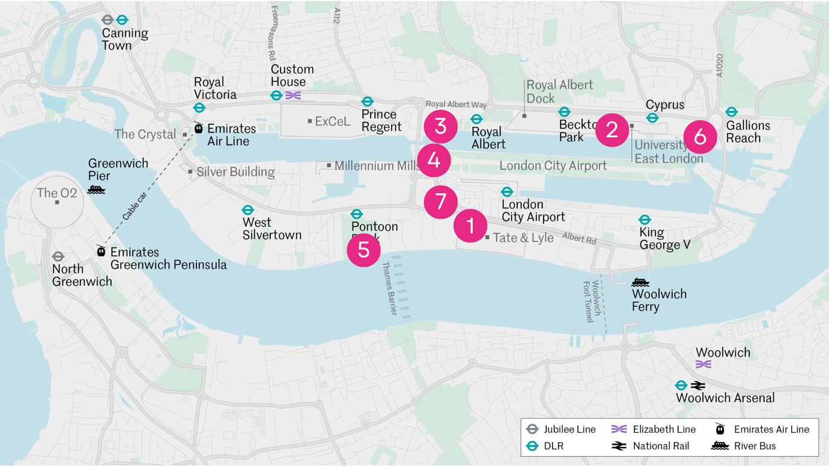

1. The Factory Project
2. London Design & Engineering UTC College
3. Connaught Crossing (North Side)
4. Connaught Crossing (South Side)
5. Thames Barrier Park
6. UEL (West of Sir Steve Redgrave Bridge)
7. North Woolwich Road
The locations above are subject to final landowner approval. Seven suggested locations are included however, only six sites will be chosen depending on landowner approval and bench designs. See appendix 1 for photos of the suggested locations.
You can indicate a preferred site in your design submission. However, please bear in mind that you might not be granted the preferred site. The design proposal should therefore be flexible and adjustable to other locations. Ultimately the decision on where benches go will be made by the Royal Docks Team.

Following the selection process, Royal Docks Team will facilitate a call/visit to a community organisation local to each bench location or provide details of existing community meetings so the design can be presented. We encourage collaboration and input from these organisations into the design. This consultation process will be used to discuss the proposed design, how it responds to the existing community feedback around seating needs in that specific area and to make sure any key feedback from the community organisation is factored in the final design.

- The brief

We are looking for benches which embrace and explore principles of the circular economy. This could be approached in a number of ways: by thinking about the longevity of the design and materials, flexibility of purpose and plans for disassembly (and reassembly). The concept of ‘waste as resource’ is central to this brief and we encourage the use of salvaged materials.

You are also invited to take inspiration from the unique context of the Royal Docks, its history and its position on the waterfront which will be explored in the Royal Docks Originals programme being delivered in October 2024.

Design Requirements

- Each bench must offer a comfortable seat for a minimum of 2 adults
- They must be safe (deter anti-social behaviour), and offer a low-cost design solution
- The designs should be playful and creative
- Consider how people of a variety of ages and physical ability could use your bench
- The benches must be easily kept clean, litter-free and in good condition. Details on how the bench should be maintained must be included within the submission
- Details of the installation should be included within the submission. The bench must be secure and be unable to be moved by the public
- The materials used for the benches must be sustainable and durable and able to withstand the very strong winds experienced around the Docks in winter months
- We are interested in seeing creative ways to reuse/recycle materials or use local materials in the bench design. If you would like support on how to access materials, please do get in touch (contact details below).
- The bench should be designed to prevent use or damage by skateboarders
- It should be weighted sufficiently or fixed to the ground to avoid being pushed over
- The seating design must protect the safety and security of passers-by and reduce the opportunity for a group of people to take it away
- The bench design must also consider all of the site conditions, any slopes and weather conditions. Benches located along the dock edge will be very exposed to the elements and at times very strong winds
- Design proposals must actively consider the surrounding communities. They should build on outcomes of community principles on the Public Realm development process to date (Appendix 2), which express communities’ needs and aspirations for public space and street furniture and demonstrate willingness to develop designs in coordination with local communities – a process the Royal Docks Team will facilitate
- Risk Assessment and Method Statement (RAMS) will be required for installation

- Further Guidance

- Authorship: The judges welcome entries from, or collaborations with groups in the Royal Docks area and LB Newham who are underrepresented in architecture. This is in line with the Mayor of London Supporting Diversity Handbook, a pdf and online version of which can be found here
- Budget: If successful, the £1,700 will need to cover all associated production and installation costs (materials, transport, construction and deinstall). You can use salvaged materials or seek in-kind materials sponsorship to reduce expenses. The budget will be managed by the entrant
- Health & safety: The drawings, risk assessment, method statement and maintenance guidance will be checked by a Royal Docks Estates Manager and landowner before approval to progress. On delivery, the bench will be checked by the landowner and designer to ensure it is safe for public use. You may be asked to make modifications but on sign-off the bench will be the property and responsibility of Royal Docks Team
- Timescale: The bench will stay in place for a year until at least Summer 2025
- Installation: Unless otherwise agreed with the Royal Docks Team installation will take place in late May 2024.
- Deinstallation: Unless otherwise agreed with the Royal Docks Team deinstallation will take place in Summer 2025. The Royal Docks Team will be responsible for the deinstallation

- Budget

The total budget available for this project for one bench is £2,200 including a design fee of £500. This is to include all fees, fabrication, installation and deinstallation costs (materials, transport and construction).
Half of the fee will be awarded on receipt of a signed agreement in which you commit to provide a bench as per your submission and any revisions as requested by Royal Docks Team and London Festival of Architecture. The remaining fee will be given in June after delivery and approval of the bench.
Depending on the location, there may also be a requirement for a licence for the bench. We will confirm if this is a requirement once your location is allocated and this cost will be covered in addition to your budget.
There will be the opportunity for designers who do not have access to studio space to fabricate their bench in London Design and Engineering UTC’s workshop. Spaces are limited and London Design and Engineering UTC require a DBS check for designers to use their workshop. Part of the project budget can be allocated to obtaining a DBS clearance, if one is not already held.
- Submission

We ask that applicants prepare a PDF (max. 10 pages) for submission that includes:
- Brief biographies of all the project team with headshots
- A 200-word description about your practice along with any relevant technical expertise acquired through previous experience
- A short paragraph of max. 300 words on why you are interested in being involved in this project
- Hand or computer drawn 3D design visualisation
- Construction detail drawn to scale, with key dimensions noted
- Outline all materials, budget and production process
- Installation process including risk assessment
- Maintenance regime in the form of an operations manual

Submission information

We are using zealous.co to administrate our application process. To submit your expression of interest for this competition, you will need to set up a free login on zealous which will enable you to begin your submission as a Draft and save it as you go. You can find information about how to submit via zealous here.

If you have any feedback on using this platform, please do let us know so we can help improve the experience of entering LFA competitions. For any questions about the competition or submission process, please email: info@londonfestivalofarchitecture.org

- Eligibility

The competition is open to students and emerging architects and designers. We welcome collaborations however the project must be actively led by a named emerging architect or designer. Emerging is defined by being no more than 7 years post graduate.

- Deadline and submission details

- Submissions open 11th October
- Deadline for submission is midday 21st November 2023. Submissions received after this time will not be considered.
- For competition enquires please contact: info@londonfestivalofarchitecture.org
- To submit expressions of interest in a PDF format go here.
- The PDF should be no more than 5MB and 10 A4 pages.
- You will receive an email confirming receipt of your submission.

- Schedule outline

Submissions open: 11th October 2023
Online Drop-in session for interested applicants: 25th October 11am – 1pm. Register here.
Submissions closed: 21st November
Judging: week beginning 27th November
Winners notified: week beginning 4th December
Meeting with client and design feedback: December 2023
Bench fabrication: Spring 2024
Benches installed: By 17th May 2024

- Judging panel

Daniel Bridge, Royal Docks Team
Joel Davis, Factory Project
Rosie Hardicker, Estate Team representative
Betty Owoo, Pews and Perches winner 2019
Michael Pecirno, HASSELL sustainability lead
Andrew Tan, Teacher of the Built Environment at London Design and Engineering UTC
Creative Connectors representative

Lydia Allain Chapman, LFA - Chair

- Judging criteria

- Initial vision - 40%: Does the proposal respond to the brief and theme with innovation, surprise and creativity? Does it explore a way to creatively embrace or test circular economy principles? How well would this design fit within the context of the Royal Docks?
- Practice/Team profile - 30% Does the team have skilled professionals for delivering the proposal in line with eligibility outlined in the Open Call? Does the team have a diverse set of skills and experience? Are the previous work experiences and/or their work methodologies and wider design aspirations relevant to the competition?
- Feasibility - 30%: Does it propose an approach which seems feasible and deliverable within the budget and set timeframe? Are the materials durable and will the bench be low maintenance?

- Further information

- Submissions will be judged on originality, demonstration of creativity and relevance to the brief, as well as feasibility and how the proposal works in the context of the site
- The ownership of Copyright of the design will be in accordance with the Copyright, Designs and Patents Act 1988, that is Copyright rests with the author of the submitted design
- All applicants will be notified of the decision of the judging panel regarding their submission, but due to the volume of applications we may not be able to provide feedback to entrants individually
- All designs remain the intellectual property of the designer however the winning designs when built, will be the property of the Royal Docks Team
- Please bear in mind that the project requires a fast turnaround and may have peak moments when your practice will need to dedicate sufficient staff to deliver the project on time, on budget and to the high standard expected by all stakeholders
- Significant efforts are made by all stakeholders of the project to ensure wide media coverage
- London Festival of Architecture and Royal Docks Team reserve the right to use images from the submissions for promotional purposes in press, social media and publications. All endeavours will be made to ensure accurate accreditation

- Useful links

London Festival of Architecture:
www.londonfestivalofarchitecture.org

The Royal Docks Team
https://www.royaldocks.london

The Royal Docks Design Guides

Please reference the Design Guides for further information on the public realm in the Royal Docks including and seating types. Entries to this competition do not need to follow the guidance in the Design Guides, we are looking for creative and new ideas for the Pew and Perches open call. https://royaldocks.london/articles/signposts-to-the-future-the-royal-docks-design-guids-are-out-now

Mayor of London Design For A Circular Economy Primer
https://www.london.gov.uk/sites/default/files/design_for_a_circular_economy_web.pdf

Building Sounds Podcast – Pews and Perches 2023
https://podcasts.apple.com/ie/podcast/london-festival-of-architecture-2023-pews-and/id1465599363?i=1000616652093

- Contact

Follow this link to submit your entry. The link will take you to an external platform zealous.co

For general enquires please contact: info@londonfestivalofarchitecture.org

- Disclaimer

The competition organisers are not liable for lost, misdirected, or late entries. Decisions of the jury represent their professional judgments and all decisions are final. While it is the intent to construct the winning scheme, the organisers reserve the right to not proceed with construction for any reason. Material submitted by you shall be your sole responsibility, shall not infringe or violate the rights of any other party or violate any laws, contribute to or encourage infringing or otherwise unlawful conduct, or otherwise be obscene, objectionable, or in poor taste. By submitting such material, you are representing that you are the owner of such material and/or have all necessary rights, licenses, and authorization to distribute it.

- References

This year will be the fifth edition of the ‘Pews and Perches’ project. The first four editions - a series of benches designed by emerging architects as part of the London Festival of Architecture (LFA)’s growing year-round programme – have been on display across the Royal Docks since autumn 2019. From a bench incorporating changing facilities for swimmers to another using reclaimed marine buoys, the benches represent extraordinarily imaginative responses to a competition organised by the LFA in partnership with the Royal Docks Team.

Together, the benches celebrate a fresh perspective on design, and offer imaginative places for the public to sit, relax and interact with the unique waterside setting. Architecture and design students, recent graduates and emerging practices were invited to enter the competition to create a playful series of benches, that can welcome visitors to the area throughout the next year. With innovative and creative visions for enlivening the Royal Docks’ distinct waterfront at the forefront of their proposals.

See the designs for the previous editions of Pews and Perches benches:
- 2023 (fourth edition)
- 2022 (third edition)
- 2020/21 (second edition)
- 2019 (first edition)

- Commissioning & Partner Organisations

The London Festival of Architecture (LFA) is a month-long celebration of architecture and city-making, taking place every June across London. The Festival’s mission is to open up discussions around architecture, test new ideas and promote emerging talent. The Festival brings together the public and built environment professionals for the whole month of June and seeks to inspire and engage our audience with a programme that showcases London as a global architecture hub. LFA is run by NLA, London’s built environment community.

www.londonfestivalofarchitecture.org
Twitter: @LFArchitecture



The Royal Docks (RDT) in the London Borough of Newham was once a global centre of innovation and industry, supplying goods and services all over the world. Today the Royal Docks prepares for London’s largest and most significant regeneration project, with up to 20,000 new homes and 40,000 jobs being delivered over the next 25 years. The Mayor of London and Mayor of Newham have established a new delivery team to drive forward the area’s exciting transformation. The team are in the process of finalising a 5-year delivery plan setting out the investment and interventions that will re-establish the Royal Docks as a world-class centre for enterprise and ideas.

www.royaldocks.london
Twitter: @YourRoyalDocks



With the spectacular view of the runway of London City Airport, London Design and Engineering UTC's vision is to create technology and employer-led education that provides learners with the ability to exceed their potential, celebrate their diversity and embrace the opportunities of the 4th industrial revolution.

www.ldeutc.co.uk

- Appendix 1

View images of the potential sites for 2024.

- Appendix 2

Read more information on the Royal Docks Community Design Principles for the Public Realm.

- Glossary

Circular Economy - A circular economy is as one where materials are retained in use at their highest value for as long as possible and are then reused or recycled, leaving a minimum of residual waste.

The London Plan - The London Plan is the statutory spatial development strategy for the Greater London area in the United Kingdom that is written by the Mayor of London and published by the Greater London Authority.

Terms that appear in pink can be found in the glossary at the end of this document.

