
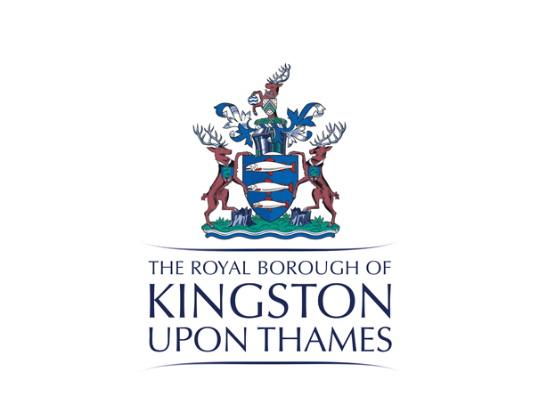


LFA Competition
Open Call
A Gateway to New Malden

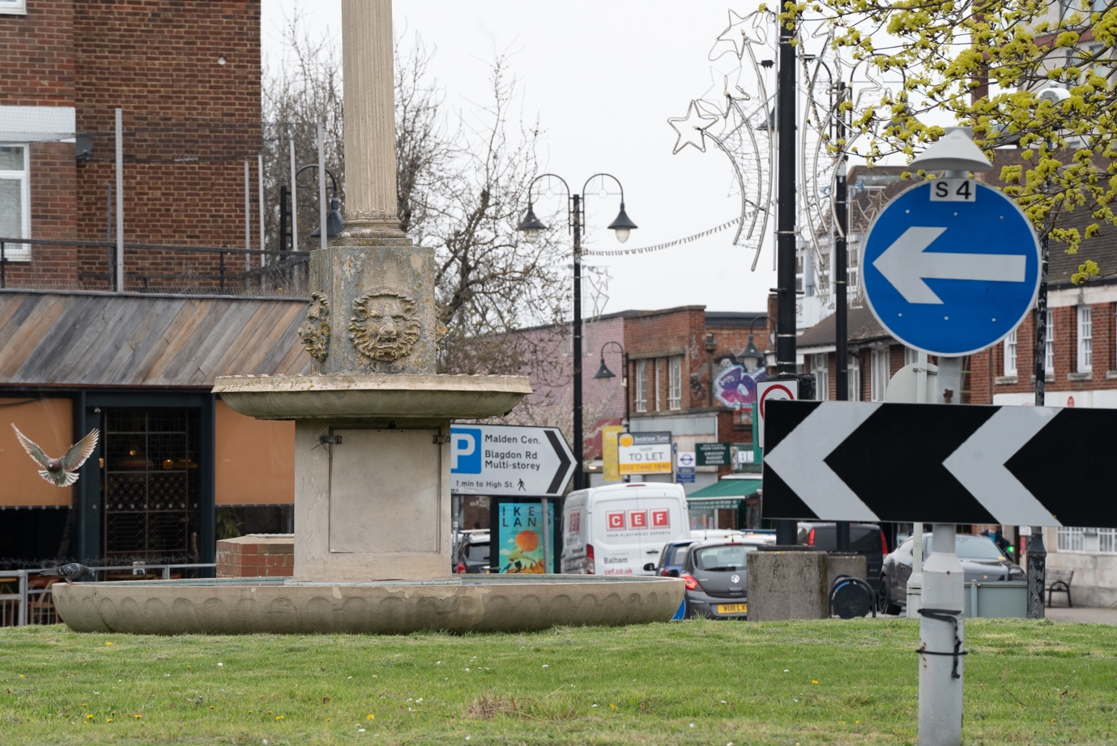
New Malden Fountain Roundabout © Kes Eccleston

The commission

The London Festival of Architecture (LFA) has partnered with the Royal Borough of Kingston upon Thames on an exciting new competition, inviting proposals to create a new visual focal point in New Malden that acts as a ‘gateway’ to the town centre. Designs will need to create an inclusive and attractive green space, define signage into the town centre and consider the town's local context and heritage.

This brief is asking designers to propose solutions for the roundabout and nearby pocket park, enhancing the green space and biodiversity, as well as for the consideration of the fountain structure to celebrate the character and heritage of New Malden and its community. The aim of the competition is to commission an innovative and creative design that will help residents make better use of the public realm so it can better serve its community.

Up to 6 teams will be shortlisted for the competition, with each team receiving an honorarium of £1,000 + VAT to the develop their proposal. A temporary exhibition of shortlisted entries will be on public display in late June, with an opportunity to register comments and feedback. A winning team will be confirmed in July and, subject to procurement and governance procedures, will be awarded a design fee to consult on and develop a fully costed, feasible design, to be installed by Summer 2024.

2
New Malden

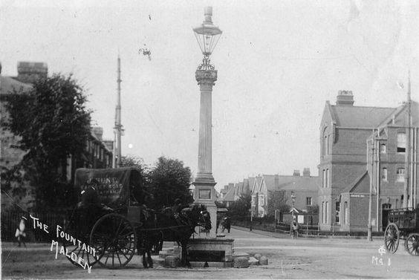
The New Malden Fountain circa 1900-1910

Whilst the area known as ‘Meldone’ appears in the Domesday Book, New Malden, as a centre, was established following the arrival of the railway line from London Waterloo in 1846; becoming an urban district in 1895 and part of the Royal Borough of Kingston Upon Thames on 1st April 1965. Prior to this, the area was largely made up of fields (including ‘Blagdon Farm’ in the East) and smallholdings. In 1876, 14 acres of Blagdon Farm was purchased by Benjamin Looker who relocated his pottery, tile and brickworks business there. Served by a striking 115 ft chimney, activity in the ovens continued through the two world wars until the chimney was demolished in 1946.

As the town has grown it has been a home to a number of new communities. New Malden today is one of the most diverse neighbourhoods in the borough of Kingston with a significant Korean and Tamil population. New Malden is generally agreed to have the largest Korean population in Europe and many Korean owned restaurants, cafes, supermarkets and karaoke bars found in the town centre.

3
Site Context
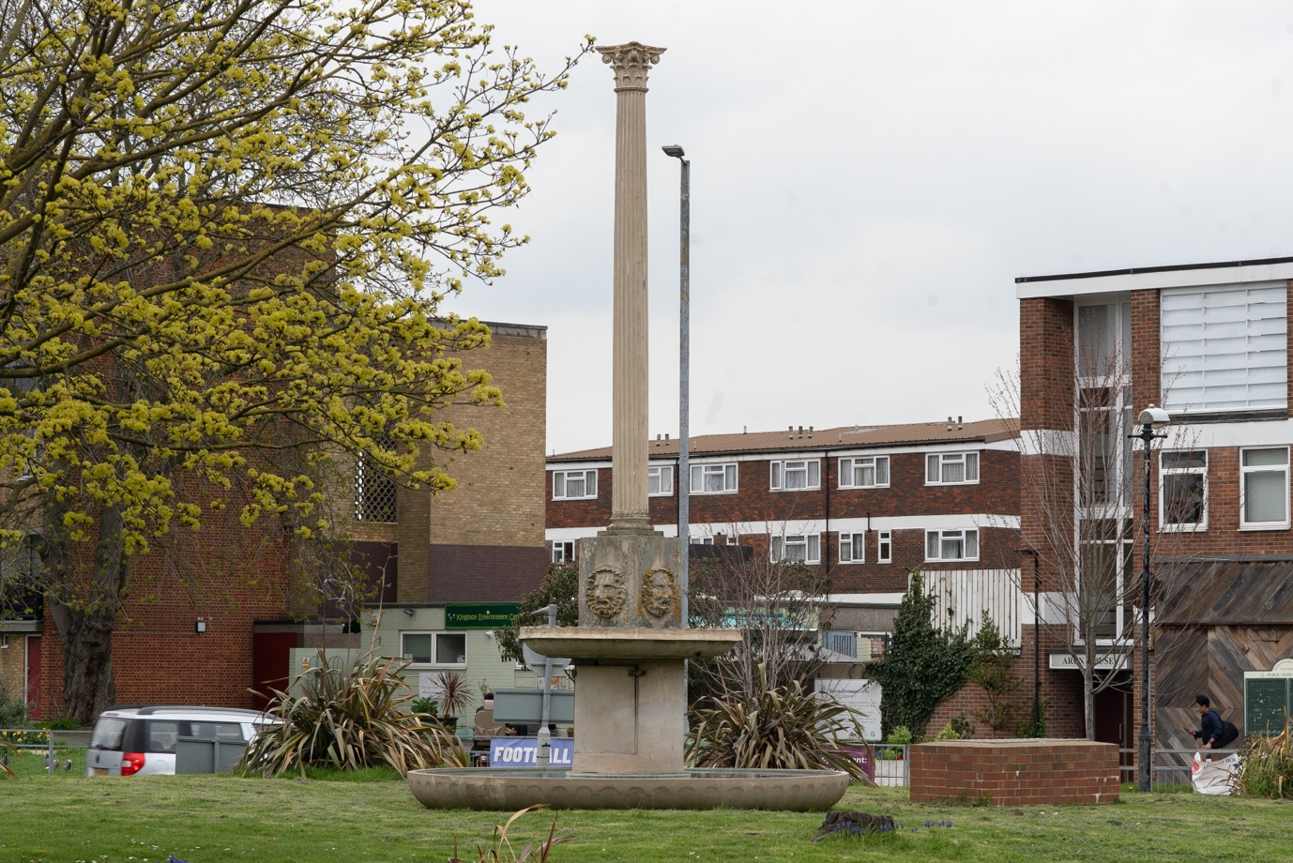
New Malden Fountain Roundabout © Kes Eccleston

This site of the roundabout and pocket park is located in New Malden’s town centre and has an important role to play in the lives of residents, workers and visitors. The site is an important through-route, both for traffic navigating the roundabout and for pedestrians accessing the Highstreet.

This scheme forms a key part of the council’s wider place making strategy to support the creation of vibrant and thriving town centres. In its current state, the site, as a key gateway does not adequately signal the arrival into New Malden, and the adjacent pocket space needs to be optimised in terms of walkability and desire lines. Previous analysis on the opportunities and constraints of this area can be found in the appendix.

The Council began engagement with local councillors and community groups in Spring 2021 who expressed a desire to address low level anti-social behaviour and provide a 'lift' to the green area. Concerns were also expressed around congestion, cycling safely, lack of a safe pedestrian crossing. However, any changes to the traffic junction layouts are out of scope for this competition.

The pocket space and the fountain which gives the roundabout its name were damaged in Storm Eunice which struck London and the South East on 18 February 2022. This provided an opportunity to reimagine the space to address local needs and aspirations.
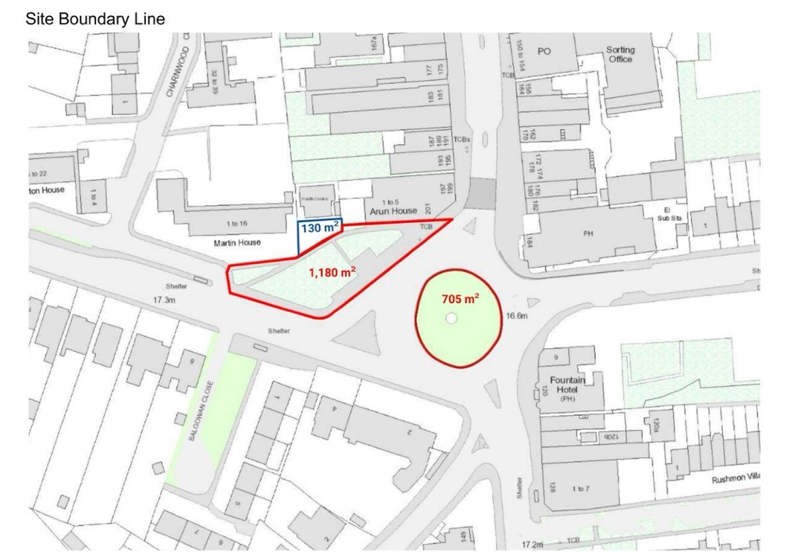

The site also shares a boundary with Kingston Environment Centre, whose aim is to promote the conservation and protection of the natural environment for the benefit of the public. This unique space is run on a voluntary basis and organises a range of events both within and outside the Environment Centre to educate the public and to encourage participation in the processes leading to a sustainable Kingston. This re-development provides an exciting opportunity to integrate the green space with the aims and objectives of the Environment Centre; to optimise the use of the outside as a short stay dwell space and increase positive planting in the public realm.

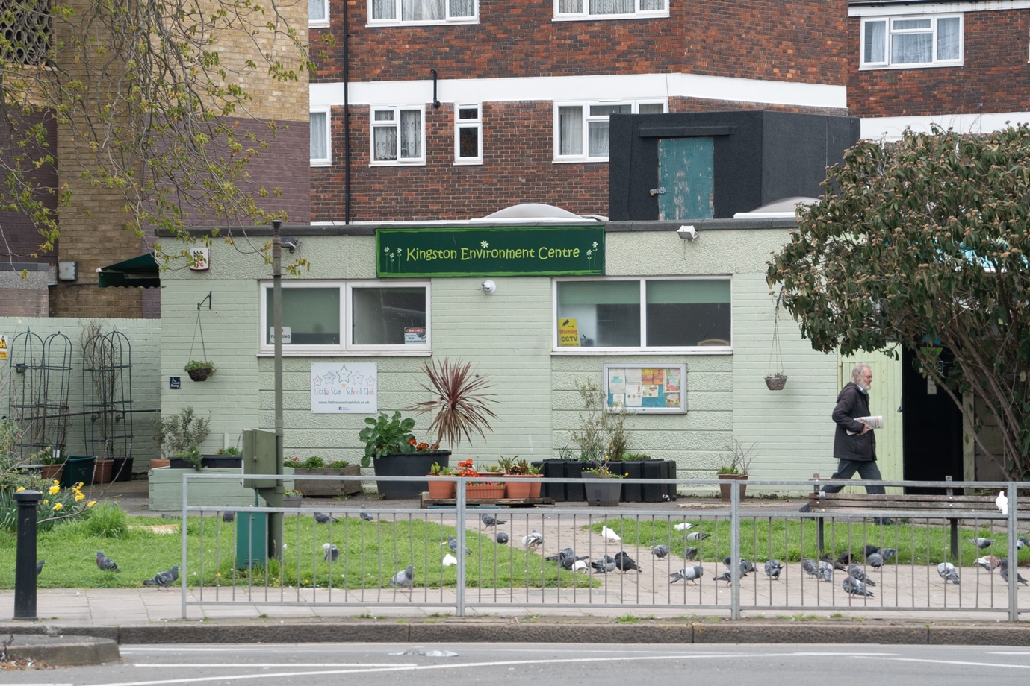
Kingston Environment Centre, view through pocket park © Kes Eccleston

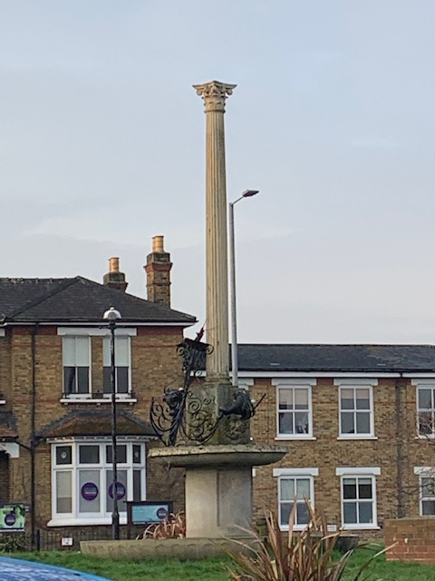
Close up of damage to the fountain following Storm Eunice
4
Community Engaged Approach

Central to Kingston’s High Street Recovery team’s methodology is using a co-design approach and we want this competition to be a continuation of this.

The design proposals need to foster participation and respond to the local context, and we are particularly looking for submissions that propose a collaborative approach with local organisations including schools, groups or residents. Changes to the area will require engagement with the local community in order to meet the needs of residents and workers and ensure local ownership and adoption of the improved green space.

We encourage proposals to take a socially engaged approach and to deliver positive outcomes for local residents and local communities. Kingston Council can provide suggested community organisations and groups, as well as guidance on collaborative and equal working relationships on request, at the shortlisting stage.

5
Design Requirement

This competition is seeking proposals for the re-landscaping of the roundabout and neighbouring green space as well as a design consideration for the fountain structure which signals this gateway into New Malden. This brief provides the opportunity to retain or re-imagine the damaged fountain, as well as the option to propose a new installation which acts as a focal point to the re-designed space.

Overall, the key objectives of the project are to deliver a scheme which:
- Celebrates the character, culture and heritage of New Malden and its community
- Signals the entry to the town centre with a significant gateway marker or art piece
- Enhances the offer of green space in the area and supports biodiversity
- Improves the pedestrian environment
- Provides a flexible, inclusive and accessible space for community use (including compliance with all relevant obligations under the Equality Act 2010)
Kingston Council’s aspirations for the landscaping would be to deliver a design that:
- Encourages biodiversity, makes provision for community planting and retains existing planting as much as possible
- Is sustainable in its use of materials and construction methods
- Creates a beautiful and inspiring environment
- Can be easily maintained throughout all seasons
- Balances the need for pathways and green space within a holistic scheme
- Includes structures/street furniture that enhance dwell time – places to sit and pause - that are both robust and attractive
- Responds to the challenges of being immediately adjacent to a busy roundabout
- Creates an actual or perceived buffer between pedestrians and traffic to create a place people will stop and stay rather than simply move through
Aspirations for the design of the new feature (replacing the broken fountain) are to:
- Create a focal point for the re-designed space
- Signal the ‘gateway’ into New Malden as the old fountain has done for over 100 years
- Install a piece which can be relevant to the local environment and community
- Is robust and easy to maintain
- Celebrates the character and heritage of New Malden and its communities

Teams are welcome to suggest the placement of the permanent installation on either the roundabout or the green.

6
Budget

The anticipated budget for delivery of this project is circa £250,000 + VAT, including the cost of implementation - materials and any necessary licences or other capital costs.

The winning team will be responsible for leading on the fabrication and installation of the design, whilst working closely with Kingston internal teams to facilitate the installation.

The budget outlined above includes an indicative amount of 12.5% of total budget to cover on-going design fees and other management costs required to deliver the winning concept.

The winning team will be expected to undertake the following tasks:
- To develop a fully costed, feasible design that can be installed by Summer 2024.
- Undertake community engagement
- Project management of the installation of winning design

7
Submissions requirements

This competition has a two stages submission.

This first stage submission should include:
- Full name and contact details including postal address, contact number and email of project lead.
- Brief biographies of all the project team.
- A 200-word description about your practice along with any relevant technical experience acquired through previous projects.
- A selection of relevant previous work, including images.
- A short paragraph of max. 500 words on why you are interested in being involved in the project and, how are you going to work with the local community to deliver your proposal if selected. Please include some thoughts about your vision including any initial written reactions you may have to the brief.
- No design work is required for the first stage.

These submissions will be shortlisted by the judging panel. Up to six shortlisted practices will then be invited to develop a design concept based on the information laid out in this open call and will be awarded an honorarium of £1,000 + VAT each. The work required for the second phase of the project will be reflective of the honorarium sum.

At shortlisting, the second stage submission should include:
- Summary information explaining your proposal and imagery to be displayed on 2 x A2 exhibition boards. Further details to be supplied at round 2
- Supporting document to be shared with the jury (max 10 pages).
  - The submission should, but is not limited to, including hand or computer drawn 3D design visualisation, key construction details drawn to scale, with key dimensions noted, an outline all materials, budget, maintenance plan and fabrication process.
- PowerPoint presentation for the purposes of judging.
- The submission should, but is not limited to, including hand or computer drawn 3D design visualisation, key construction details drawn to scale, with key dimensions noted, an outline all materials, budget, maintenance plan and fabrication process.

Submission information
For any questions about the competition or submission process, please email: lydia.allainchapman@nla.london

8
Eligibility

The competition is open to architects, landscape architects, designers and artists. We welcome collaborations; however, the project team must include a qualified architect or landscape architect.
Representation within this project is a crucial factor we wish to capture in order to achieve spaces that are purpose built for local residents and reflective of who they are. The judges encourage entries from, or collaborations with, individuals and groups who are underrepresented in architecture and/or that operate as SMEs or micro enterprises.
Following appointment, the chosen individual / team can work with local stakeholders to develop ideas into more detailed design concepts. We therefore invite artists and creatives from within New Malden, across Kingston and beyond, to submit their ideas for this commission.

9
Deadline and submission details

- Deadline for first submission is Midday, 11 May. Submissions received after time this will not be considered.
- For competition enquiries please contact: info@londonfestivalofarchitecture.org
- To send your expression of interest in a PDF format go here.
- The PDF should be no more than 5MB and 10 A4 pages.
- You will receive an email confirming the receipt of your submission.

10
Schedule outline

Submissions open: 14 April
Submissions closed: 11 May, midday
Successful shortlisted teams notified: w/c 22 May
Site visit with shortlisted teams: Friday 26th May, 10am
Round 2 submission deadline: 15 June
Exhibition of shortlisted submissions: 22 - 25 June
Final judging / interviews: w/c 3 July
Winner notified: w/c 10 July

11
Judging panel

Chair – Benjamin O’Connor, Director, NLA

Nkechi Okeke-Aru, The Royal Borough of Kingston upon Thames, Highstreet Recovery Lead
The Royal Borough of Kingston upon Thames, Highways Representative
Pat Dobson, Director, Kingston Environment Centre
Melodie Leung, Associate Director, Zaha Hadid Architects
Micheal Cowdy, Director, McGregor Coxall
Hadi Yassin, First year Architecture student, Kingston University

12
Judging criteria

Round 1 Judging Criteria
- Practice/Team profile - 40% Does the team have skilled professionals for delivering the proposal in line with eligibility outlined in the Open Call? Does the team have a diverse set of skills and experience? Are the previous work experiences and/or their work methodologies and wider design aspirations relevant to the competition?
- Initial vision - 30%: Does the proposal's initial written reflection to the brief suggest innovation, surprise and creativity? Does it explore a new and original way to use and engage with the area?
- Feasibility - 30%: Does it propose an approach which seems feasible and deliverable within the budget and set timeframe?

Round 2 Judging Criteria
- Overall design – 30%
- Costs/feasibility – 25%
- Approach to environment and sustainability – 15%
- Longevity and implications for maintenance – 15%
- Contextual design and public engagement – 15%

13
Further information

- Submissions will be judged on originality, demonstration of creativity, relevance to the brief as well as feasibility and how the proposal works in the context of the site.
- To process entries to this competition we will share your application and any associated personal data provided on the application with our jury and competition partners.
- All applicants will be notified of the outcome of their application, but due to the volume of submissions we may not be able to provide feedback to entrants individually.
- Applicants may not be assisted in any way in their submission by members of the judging panel, the client body, organisers, members of their family, close business associates or employees.
- The ownership of Copyright of the design will be in accordance with the Copyright, Designs and Patents Act 1988, that is Copyright rests with the author of the submitted design.
- All designs remain the intellectual property of the designer however the winning design will itself when built will be the property of the landowners.
- Please bear in mind the project requires a fast turn around and may have peak moments when your practice will need to dedicate sufficient staff to deliver the project on time, to budget and to the high standard expected by all stakeholders.
- If your practice/collaboration is appointed to deliver the project it will need to have the following insurance: Employers Liability, Professional Indemnity, Public Liability.
- Significant efforts are made by all stakeholders of the project to ensure wide media coverage.
- LFA reserve the right to use images from the submissions for promotional purposes in press, social media and publications. All endeavours will be made to ensure accurate accreditation.

14
Useful links

London Festival of Architecture:
www.londonfestivalofarchitecture.org

Kingston Environment Centre:
https://kingstoneco.org.uk/about/

Cocks Crescent SPD
Large-scale mixed use development scheme not far from the fountain site
https://www.kingston.gov.uk/downloads/file/267/cocks-crescent-spd-april-2017-

15
Appendix

Fountain Scheme Opportunities and Constraints (RBK), click to download

16
Contact

To submit your entry please go here.

For general enquiries please contact: lydia.allainchapman@nla.london

17
Disclaimer

The competition organisers are not liable for lost, misdirected, or late entries. Decisions of the jury represent their professional judgments and all decisions are final. While it is the intent to construct the winning scheme, the organisers reserve the right to not proceed with construction for any reason. Material submitted by you shall be your sole responsibility, shall not infringe or violate the rights of any other party or violate any laws, contribute to or encourage infringing or otherwise unlawful conduct, or otherwise be obscene, objectionable, or in poor taste. By submitting such material, you are representing that you are the owner of such material and/or have all necessary rights, licences, and authorization to distribute it.

18
Commissioning organisations

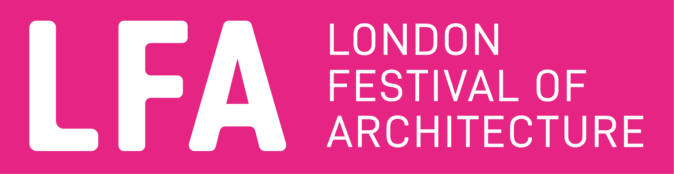

The London Festival of Architecture (LFA) is the world’s largest annual architecture festival and will be exploring the theme of ‘act’ in 2022. The LFA is part of New London Architecture (NLA), and has a mission is to support London’s architectural and design talent, enthuse and engage with the public, and find new ways to look at familiar places. In 2021 the LFA explored the theme of care, and celebrated innovation and design through a hybrid programme of activity last June. A year-round programme of design competitions, design charrettes, campaigns and other activities also champions London as the best place in the world to practice and enjoy architecture.
www.londonfestivalofarchitecture.org
Twitter: @LFArchitecture
Instagram: @LondonFestivalofArchitecture

The Royal Borough of Kingston Upon Thames.
This special place in South West London between the capital and the country has been a Royal borough longer than anywhere else - it is where the first kings of England were crowned.

Kingston’s people are innovative and entrepreneurial, and have a strong sense of community pride. The borough has been home to great industry and creativity for many years, reflected in assets such as the Rose Theatre, the International Youth Arts Festival and Kingston University, which boasts more new graduate business start-ups than any other.

Kingston is home to people from diverse and interesting cultures and backgrounds, which helps to create the rich sense of community shared across the borough. In particular, Kingston has a large Sri Lankan Tamil community and New Malden is home to Europe’s largest Korean community.

https://www.kingston.gov.uk/
Twitter: @RBKingston
Instagram: @kingston_council
Facebook: @Kingston Council

This was not the first incident to cause damage to the monument in its long history. First built in stone in 1894, the fountain suffered damage at the hand of two car accidents which cause the structure to be moved in 1932 and then finally replaced by a fibreglass replica in 1982, funded by the Rotary Club. Long before the storm in 2022 the fibreglass structure had fallen into disrepair and was no longer a working fountain.

