

LFA Competition
LFA2023 Tote Bag Design Competition

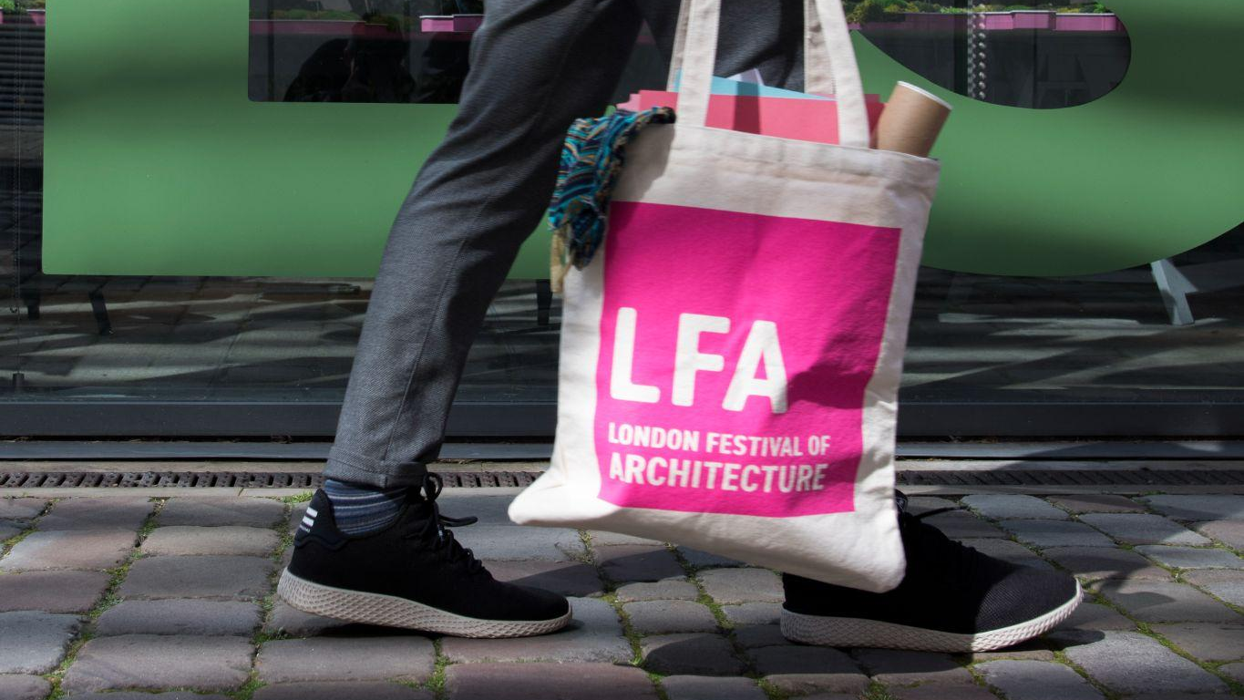

The Commission

The London Festival of Architecture is reaching out to its festival community - including architects, artists, or those with a keen interest in architecture - to submit a unique design which will form the base of our LFA2023 merchandise and promotion.

Across the years, the festival has produced a variety of tools and merchandise for our event organisers and key partners to help support and promote the work of the Festival. However, for the first time, we’ve decided to open up the design of this year’s tote bag to our festival community.

We are looking for a graphic or illustration which responds to the LFA2023 theme of ‘In Common’. This theme encourages us to reflect on what we share (whether that be the finite number of natural resources, physical ‘commons’, public spaces and stories) and also what we don’t have in common in order to ensure that we work with those with different lived experiences when thinking about the future of our city.

The winner will be revealed on 10th April and awarded £500 + VAT for their design. The chosen design will be used to promote the London Festival of Architecture 2023, displayed on LFA tote bags and other key merchandise.

About LFA2023

The London Festival of Architecture (LFA) is a month-long celebration of architecture and city-making, taking place every June across London. Our mission is to open up discussions around architecture, test new ideas and promote emerging talent.

The London Festival of Architecture began in 2004 and has since grown to become Europe's biggest annual architecture festival. The festival attracts a vast public audience and a global media audience of millions. The vast majority of events are free and are staged by a core festival programming team working alongside architecture and design practices and practitioners, leading cultural and academic institutions, artists and many others.

What makes the LFA unique is that the LFA programme is people-led and curated by event organisers; we believe in the power of collaboration with the people who live, shape, and truly know London. It’s the breadth and creativity of this community that deliver such a varied and engaging programme of events for the festival each June. We work year-round to help individuals and organisations feel empowered to stage their own Festival events and welcome everyone into the conversation around architecture and our city.

‘In Common’ Theme

For the second year we asked our network of event organisers, supporters and followers to suggest a theme for the Festival. The proposals were then considered by the Festival’s curatorial panel, who selected ‘In Common’ as a theme with multiple meanings and associations that will allow event organisers – large and small, old and new – to produce a rich and varied programme celebrating architecture on London’s public and global stage.

We have more in common than we know. But how do we create and shape the space we share: our city? How do we make the most of what we have in common – and explore the things we don’t?

Read more about our theme here.

Design Requirements

Your design should:
- Respond creatively to the LFA’s theme ‘In Common’
- Not exceed W 28.5cm x H 30cm
- Be no smaller than 18cm x 20cm

Other considerations
- Your design should be able work successfully on a neutral background, printed in monochrome.
- Please supply your design in any of the following hi-res formats: .pdf, .eps, .jpeg
- Please do not include any text within your design
- The LFA logo will be included elsewhere on the Tote Bag – please do not include the logo or other branding in your design
- Please consider whether your design is representation of a London for all Londoners, not singling out a particular area, industry or group of people
- We will accept submissions in all formats including hand drawn or computer drawn images.

For this competition we also ask you for a short written reflection (max.200 words) on your design detailing how you have responded to the brief. As well as a background of yourself and your connection/experience with the Festival.

Eligibility
The competition is open to anyone from the LFA community, with an interest and enthusiasm for architecture, the city and the festival.
Whether you are an artist, designer, student, architect, event organiser or somebody with enthusiasm for LFA, we want to hear from you.

Deadline and Submission Details

Please submit your design and written reflection as a pdf via this link.

If you are unable to submit via the link, and require an alternative method, please email us at info@londonfestivalofarchitecure.org or call 020 7636 4044 (and asking for Eliza or Lydia.)

- Deadline for first submission is midday, Monday 6th March.
- Submissions received after time this will not be considered.
- For competition enquiries please contact: info@londonfestivalofarchitecture.org
- To send your expression of interest (in a PDF format), click this link here.
- The PDF should be no more than 5MB and 4 A4 pages.
- You will receive an email confirming the receipt of your submission.

Precedents

LFA2022: incorporating significant pieces of architecture from each of the 2022 destinations.

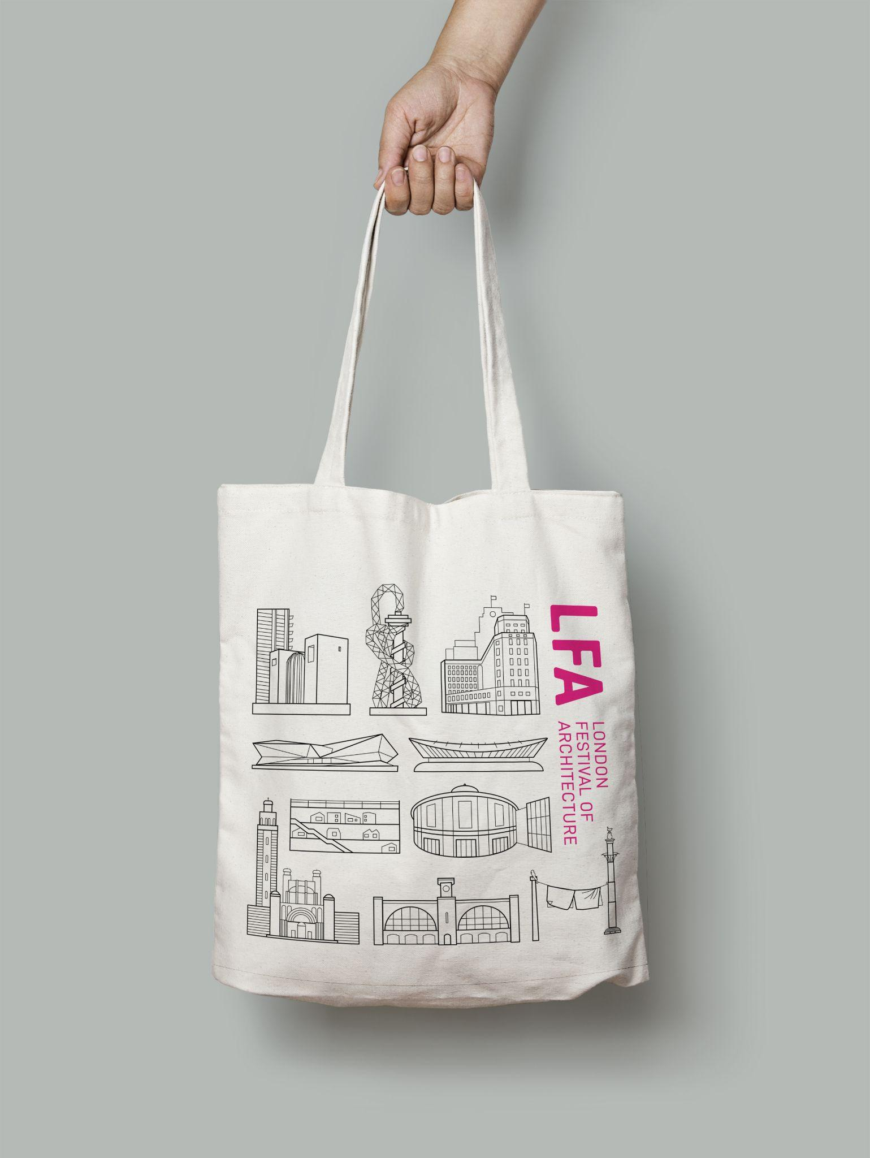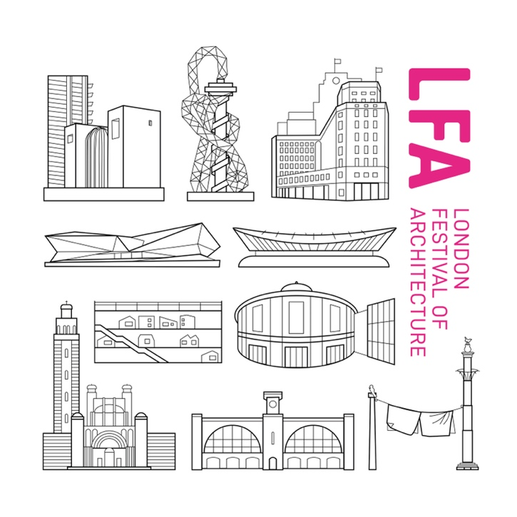

LFA2019: focusing on the simplicity of the brand, whilst playing on words with the letters of LFA. Please note, this design is using the previous version of the logo, it has since been updated.

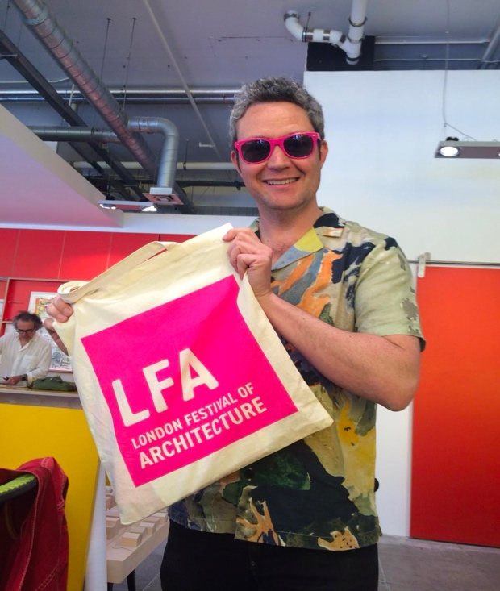
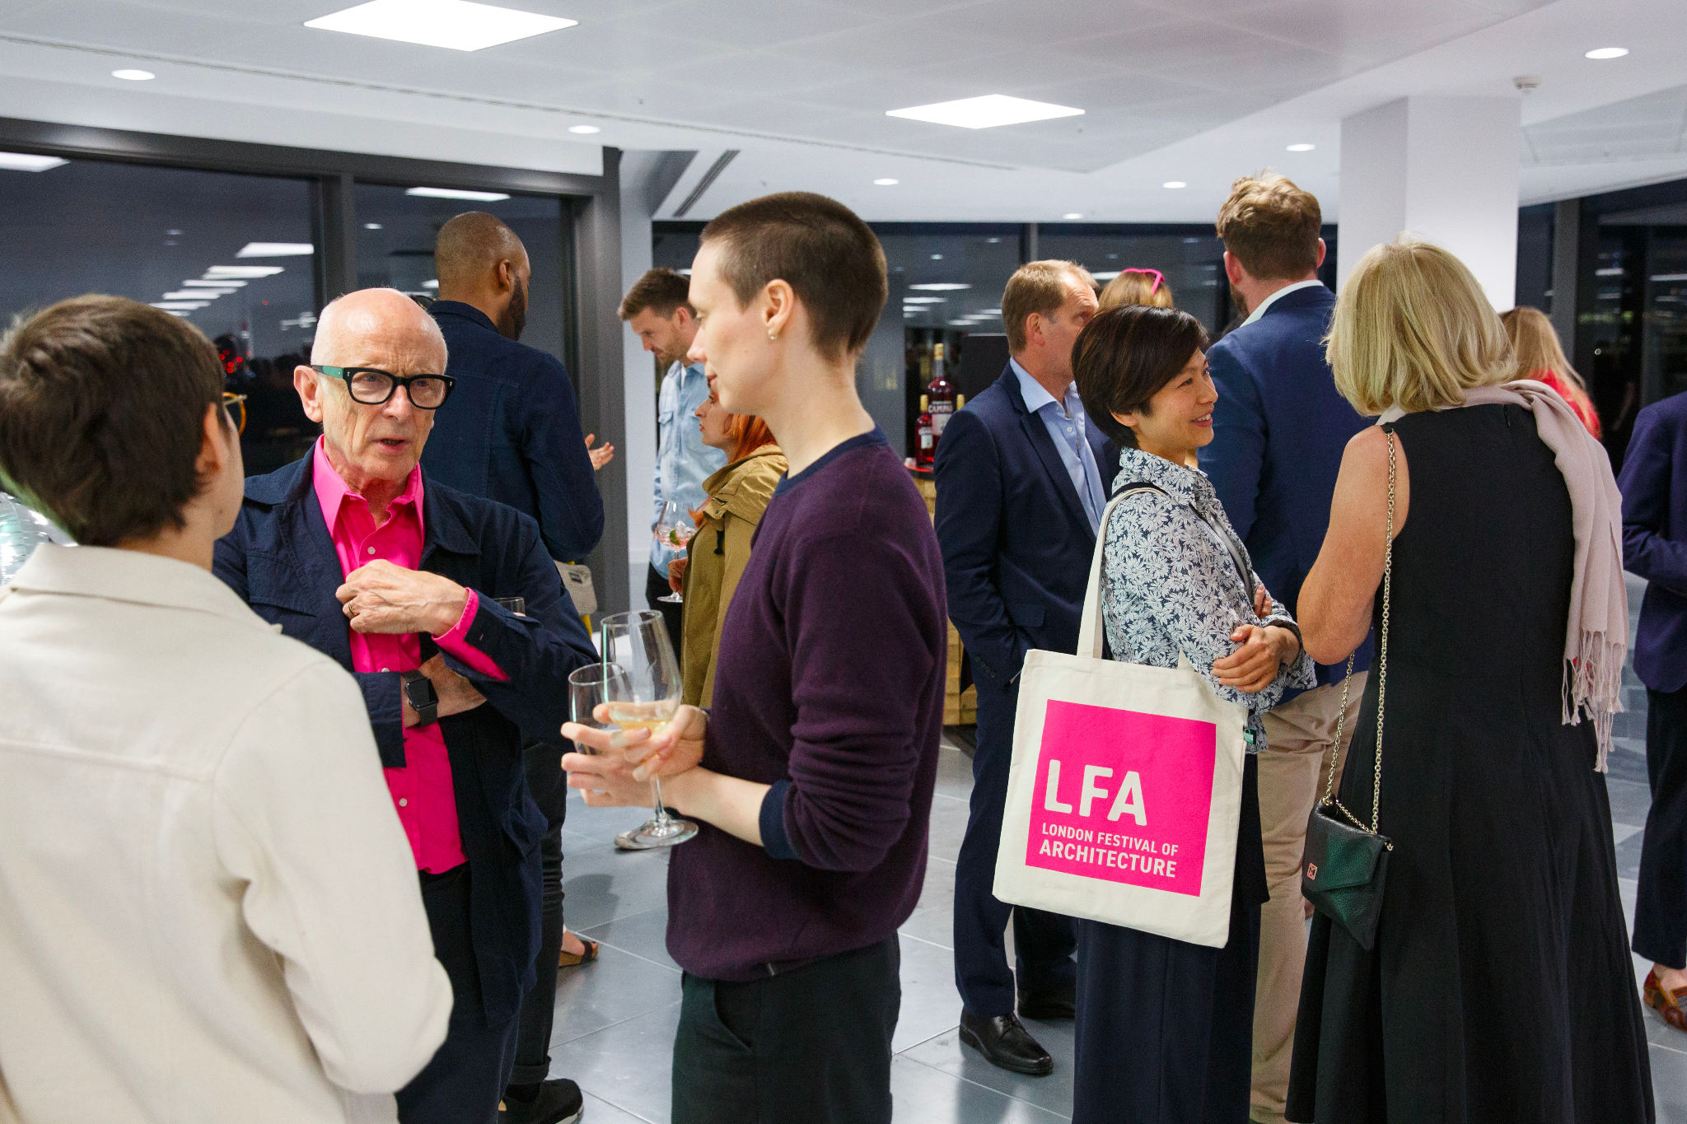

LFA2018: focusing on brand colours, whilst sharing a themed quote. Please note, this design is using the previous version of the logo, it has since been updated.
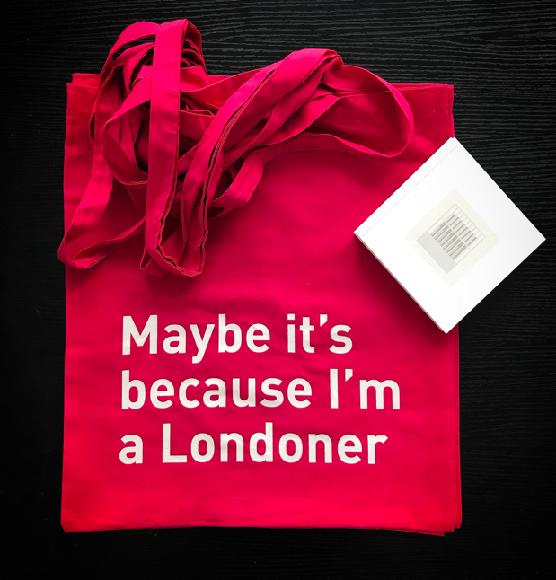
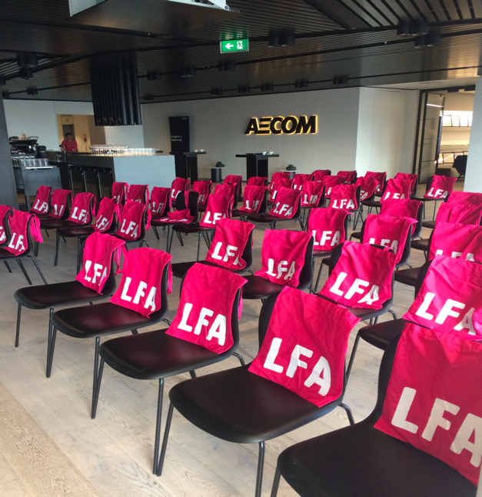

Further Information

- Submissions will be judged on originality, demonstration of creativity, relevance to the brief as well as how the proposed design works in the context of the chosen outputs.
- The chosen design will be selected by the LFA Team and the 2023 curation panel.
- The ownership of Copyright of the design will be in accordance with the Copyright, Designs and Patents Act 1988, that is Copyright rests with the author of the submitted design.
- All applicants will be notified of the outcomes, but due to the volume of applications we may not be able to provide feedback to entrants individually.
- LFA reserve the right to use images from the submissions for promotional purposes in press, social media and publications. All endeavors will be made to ensure accurate accreditation.
- The final design may need to be adjusted in accordance with design templates and additional print formats.
- The final design may be used on other key LFA merchandise e.g. posters, guidebook, digital assets.

Useful links

‘In Common’ Theme Reflections - https://www.londonfestivalofarchitecture.org/media-item/in-common-reflections-from-the-curation-panel/

LFA Destinations 2023 - https://www.londonfestivalofarchitecture.org/destinations/

Disclaimer

The competition organisers are not liable for lost, misdirected, or late entries. While it is the intent to print the winning design, the organisers reserve the right to not proceed with this for any reason. By submitting material, you are representing that you are the owner of such material and/or have all necessary rights, licenses, and authorization to distribute it.

