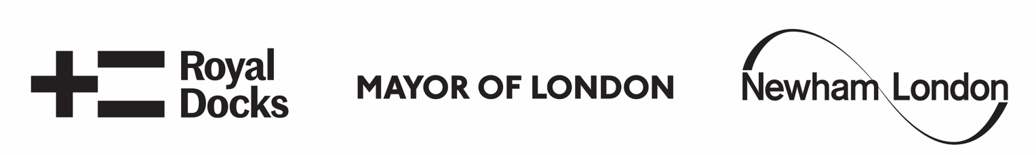

Open Call
Pews & Perches 2023
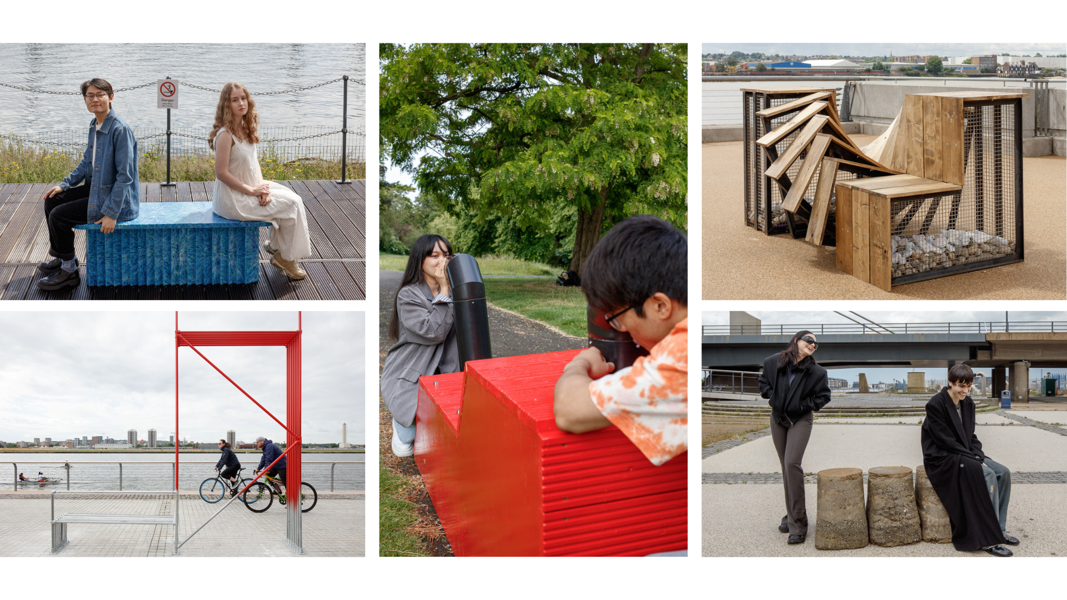
Winning benches from 2022 © Luke O'Donovan

- The commission

The London Festival of Architecture (LFA) and The Royal Docks Team (RDT) are inviting architecture and design students, recent graduates and emerging practitioners to
create one of several public benches, to be installed in the public realm of the Royal Docks in 2023.

Now in its fourth edition, this competition is seeking design proposals that encourage those who live, work in and visit the Royal Docks to come together and have meaningful exchanges within the public realm. To be installed as part of the LFA in June 2023 and to be onsite for at least a year, we are asking designers to respond to this festival year’s theme ‘in common’, creating a bench that facilitates and celebrates the ways in which communities share experiences and resources, including public space.

The competition invites you to share your unique perspective on the theme ‘in common’ through the design of each bench. Consider what people have in common (or what they don’t) when they gather in and use public space as well as the diversity of users and communities in the Royal Docks. Is there adequate provision for the needs of the community in public seating already provided?

If your design is one of the winners, you will be awarded £2,100 (including a design fee of £500) to develop, build and install your bench in the Royal Docks. This will be a chance to participate in a unique project and showcase your imaginative design to the public and the many festival producers, as well as the opportunity to be involved in events held through LFA 2023.

This year, five benches will be installed in the Royal Docks; four selected from this design competition open to emerging architects and designers, with the fifth bench being designed by a student team from UTC college in the Royal Docks, mentored by previous competition winner, Andre Kong.

- The Context

Royal docks
Once London’s gateway to world trade, today the Royal Docks is one of the UK’s most important regeneration stories. This vast area in the London Borough of Newham is re-emerging as a commercial and cultural hub of global significance, and an exciting new waterfront.

The docks lie immediately east of Canary Wharf, covering over 500 hectares of land and 18.4km of waterfront. With the support of funding from the London Economic Partnership (LEAP), this unique part of London is starting a journey to become one of the best examples of regeneration in the world. Located at the intersection of the Thames Estuary, Royal Docks and Beckton Riverside Opportunity Area, and the UK's Innovation Corridor, this is a large area with enormous potential. Through cooperating across municipal borders, the Royal Docks is poised to become a flourishing and diverse commercial district.

The Royal Docks Team is a multi-disciplinary team that brings together officers from across the Greater London Authority, the London Borough of Newham and the London Economic Action Partnership. The team was established in 2017 to help deliver the cohesive transformation of the Royal Docks Enterprise Zone, where seven million sq ft of commercial space will see business rates reinvested for the benefit of the local community.

LFA 2023 theme

We live in a state of multiple crises: climate, health, class, and race have highlighted a wide spectrum of systematic inequalities our cities hold; from lack of affordable housing to obvious gaps in provision of greenspaces and other natural resources. Discussion and debate online and in person can revolve around our differences. But this is not inherently negative; discussing what we don’t have in common is an important part of improving our built environment, ensuring we are working with those with different lived experiences who interact with cities in the ways that we don’t. In some cases, architects, developers, and planners may not have much in common with the people who use the spaces they’re creating – what effect does this have on our city?

The LFA’s theme for 2023 is ‘In Common’. Throughout the Festival, we hope to explore and interrogate how the experiences we do and don’t have in common are central to the evolution and development of the city. Our community holds knowledge, skills and understanding to find solutions to the real-life challenges we face, and we look forward to bringing these explorations together in June 2023. The Royal Docks is the perfect context in which to test out some of the ideas provoked by this theme within public space. With the borough of Newham which has a diverse, young population, the Royal Docks is working hard within their Public Realm Framework to ensure that their public space feels inviting, safe and accessible to all communities in the area.

- The sites
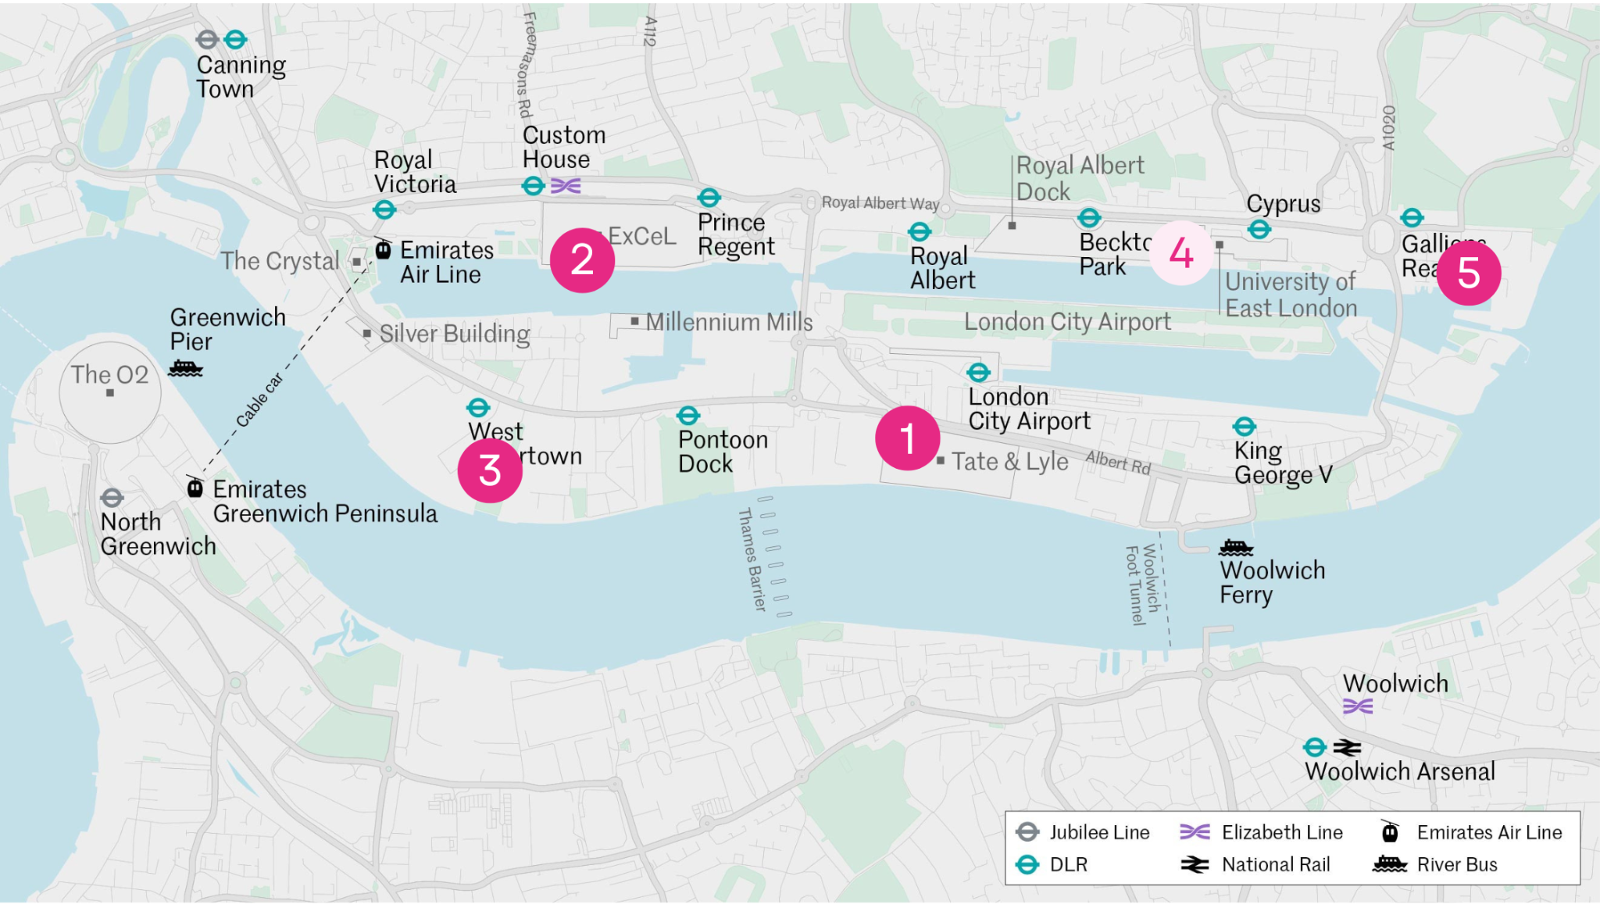
A variety of locations across the Royal Docks have been selected for the Pews and Perches. These are areas where there is significant scope for public realm enhancement or seating provision:

- The Factory Project, Factory Rd, London E16 2HB
- Royal Victoria Dock Floating Garden (in addition to What A Water Waste! bench from 2023).
- Lyle Park
- London Design & Engineering UTC College (to be designed by students from UTC)
- Royal Albert Wharf

The locations above are subject to final landowner approval. See appendix 1 for photos of the suggested locations.

You can indicate a preferred site in your design submission. However, please bear in mind that you might not be granted the preferred site. The design proposal should therefore be flexible and adjustable to other locations. Ultimately the decision on where benches go will be made by the Royal Docks Team.

Following the selection process, Royal Docks Team will facilitate a call/visit to a community organisation local to each bench location or provide details of existing community meetings so the design can be presented. We encourage collaboration and input from these organisations into the design. This consultation process will be used to discuss the proposed design, how it responds to the existing community feedback around seating needs in that specific area and to make sure any key feedback from the community organisation is factored in the final design.

- Design requirements

- Each bench must offer a comfortable seat for a minimum of 2 adults, however, as this brief is asking you to consider how communities come together in the public realm, you may wish to consider a larger scale piece or non traditional bench style.
- They must be safe (deter anti-social behaviour), and offer a low-cost design solution
- The designs should be playful and creative
- The benches must be easily kept clean, litter-free and in good condition. Details on the how the bench should be maintained must be included within the submission
- Details of the installation should be included within the submission. The bench must be secure and be unable to be moved by the public
- The materials used for the benches must be sustainable and durable and able to withstand the very strong winds experienced around the Docks in winter months
- We are interested in seeing creative ways to reuse/recycle materials or use local materials in the bench design
- The bench should be designed to prevent use or damage by skateboarders
- It should be weighted sufficiently or fixed to the ground to avoid being pushed over
- The seating design must protect the safety and security of passers-by and reduce the opportunity for a group of people to take it away
- Benches on the Floating Gardens should be light weight and fixed to the decking, they should also be considerate of the restricted space on the pontoon
- The bench design must also consider all of the site conditions, any slopes and weather conditions. Benches located along the dock edge will be very exposed to the elements and at times very strong winds.
- Design proposals must actively consider the surrounding communities. They should build on outcomes of community principles on the Public Realm development process to date (Appendix 2), which express communities’ needs and aspirations for public space and street furniture and demonstrate willingness to develop designs in coordination with local communities – a process the Royal Docks Team will facilitate.
- Risk Assessment and Method Statement (RAMS) will be required for installation.

- Further Guidance

- Authorship: The judges welcome entries from, or collaborations with groups in the Royal Docks area and LB Newham who are underrepresented in architecture. This is in line with the Mayor of London’s recently launched Supporting Diversity Handbook, a pdf and online version of which can be found here.
- Budget: If successful, the £1,600 will need to cover all associated production and installation costs (materials, transport, construction and deinstall). You can use salvaged materials or seek in-kind materials sponsorship to reduce expenses. The budget will be managed by the entrant.
- Health & safety: The drawings, risk assessment, method statement and maintenance guidance will be checked by a Royal Docks Estates Manager before approval to progress. On delivery, the bench will be checked by the landowner and designer to ensure it is safe for public use. You may be asked to make modifications but on sign-off the bench will be the property and responsibility of Royal Docks Team.
- Timescale: The bench will stay in place for a year until at least Summer 2024.
- Installation: Unless otherwise agreed with the Royal Docks Team installation will take place in late May 2023.
- Deinstallation: Unless otherwise agreed with the Royal Docks Team deinstallation will take place in Summer 2024. The Royal Docks Team will be responsible for the deinstallation.

- Budget

The total budget available for this project for one bench is £2,100 including a design fee of £500. This is to include all fees, fabrication, installation and deinstallation costs (materials, transport and construction).
Half of the fee will be awarded on receipt of a signed agreement in which you commit to provide a bench as per your submission and any revisions as requested by Royal Docks Team and London Festival of Architecture. The remaining fee will be given in June after delivery and approval of the bench.
Depending on the location, there may also be a requirement for a licence for the bench. We will confirm if this is a requirement once your location is allocated and this cost will be covered in addition to your budget.

- Submission

This submission should include
1. Full name and contact details including postal address, contact number and email of project lead.
2. Brief biographies of all the project team.
3. Coloured photo of the design team (landscape) for promotional purposes
4. A 200-word description about your practice along with any relevant technical expertise acquired through previous experience.
5. Hand or computer drawn 3D design visualisation
6. Construction detail drawn to scale, with key dimensions noted
7. Outline all materials, budget and production process
8. Installation process including risk assessment.
9. Maintenance regime in the form of an operations manual.

Submission information

For any questions about the competition or submission process, please email: lydia.allainchapman@nla.london

- Eligibility

The competition is open to students and emerging architects and designers. We welcome collaborations however the project must be actively led by a named emerging architect or designer. Emerging is defined by being no more than 7 years post graduate.

- Deadline and submission details

- Deadline for submission is midday 1st December 2022. Submissions received after this time will not be considered.
- For competition enquires please contact: lydia.allainchapman@nla.london
- To submit expressions of interest in a PDF format go here
- The PDF should be no more than 5MB and 10 A4 pages.
- You will receive an email confirming receipt of your submission.

- Schedule outline

Submissions open: 20th October 2022
Submissions closed: 1st December 2022
Winners notified: w/c 12th December 2022
Bench fabrication: January 2023 – May 2023
Benches installed: w/c 29th May 2023

- Judging panel

Daniel Bridge, Royal Docks Team
Estate Team representative
Public Spaces Community Working Group representative
Creative Connectors representative
Andre Kong, Andre Kong Studio, Mentor for UTC
Rosa Rogina (Director, LFA) - Chair

- Judging criteria

- Initial vision - 40%: Does the proposal respond to the brief and theme with innovation, surprise and creativity? Does it explore a new and original way to use and engage with the community living in and visiting the Royal Docks?
- Practice/Team profile - 30% Does the team have skilled professionals for delivering the proposal in line with eligibility outlined in the Open Call? Does the team have a diverse set of skills and experience? Are the previous work experiences and/or their work methodologies and wider design aspirations relevant to the competition?
- Feasibility - 30%: Does it propose an approach which seems feasible and deliverable within the budget and set timeframe? Are the materials durable and will be bench be low maintenance?

- Further information

- Submissions will be judged on originality, demonstration of creativity and relevance to the brief, as well as feasibility and how the proposal works in the context of the site.
- The ownership of Copyright of the design will be in accordance with the Copyright, Designs and Patents Act 1988, that is Copyright rests with the author of the submitted design.
- All applicants will be notified of the decision of the judging panel regarding their submission, but due to the volume of applications we may not be able to provide feedback to entrants individually.
- All designs remain the intellectual property of the designer however the winning designs when built, will be the property of the Royal Docks Team.
- Please bear in mind that the project requires a fast turnaround and may have peak moments when your practice will need to dedicate sufficient staff to deliver the project on time, on budget and to the high standard expected by all stakeholders.
- Significant efforts are made by all stakeholders of the project to ensure wide media coverage.
- London Festival of Architecture and Royal Docks Team reserve the right to use images from the submissions for promotional purposes in press, social media and publications. All endeavours will be made to ensure accurate accreditation.

- Useful links

London Festival of Architecture:
www.londonfestivalofarchitecture.org

The Royal Docks Team
https://www.royaldocks.london

The Royal Docks Design Guides

Please reference the Design Guides for further information on the public realm in the Royal Docks including and seating types. Entries to this competition do not need to follow the guidance in the Design Guides, we are looking for creative and new ideas for the Pew and Perches open call. https://royaldocks.london/articles/signposts-to-the-future-the-royal-docks-design-guids-are-out-now

- Contact

Follow this link to submit your entry.

For general enquires please contact: lydia.allainchapman@nla.london

- Disclaimer

The competition organisers are not liable for lost, misdirected, or late entries. Decisions of the jury represent their professional judgments and all decisions are final. While it is the intent to construct the winning scheme, the organisers reserve the right to not proceed with construction for any reason. Material submitted by you shall be your sole responsibility, shall not infringe or violate the rights of any other party or violate any laws, contribute to or encourage infringing or otherwise unlawful conduct, or otherwise be obscene, objectionable, or in poor taste. By submitting such material, you are representing that you are the owner of such material and/or have all necessary rights, licenses, and authorization to distribute it.

- References

This year will be the fourth edition of the ‘Pews and Perches’ project. The first three editions - a series of benches designed by emerging architects as part of the London Festival of Architecture (LFA)’s growing year-round programme – have been on display across the Royal Docks since autumn 2019. From a bench incorporating changing facilities for swimmers to another using reclaimed marine buoys, the benches represent extraordinarily imaginative responses to a competition organised by the LFA in partnership with the Royal Docks Team.

Together, the benches celebrate a fresh perspective on design, and offer imaginative places for the public to sit, relax and interact with the unique waterside setting. Architecture and design students, recent graduates and emerging practices were invited to enter the competition to create a playful series of benches, that can welcome visitors to the area throughout the next year. With innovative and creative visions for enlivening the Royal Docks’ distinct waterfront at the forefront of their proposals.

See the designs for the Pews and Perches benches 2022.

- Commissioning Organisations

The London Festival of Architecture (LFA) is the world’s largest annual architecture festival. The LFA is part of New London Architecture (NLA), and its mission is to support London’s architectural and design talent, enthuse and engage with the public, and find new ways to look at familiar places. A year-round programme of design competitions, design charrettes, campaigns and other activities also champions London as the best place in the world to practise and enjoy architecture.

www.londonfestivalofarchitecture.org
Twitter: @LFArchitecture



The Royal Docks (RDT) in the London Borough of Newham was once a global centre of innovation and industry, supplying goods and services all over the world. Today the Royal Docks prepares for London’s largest and most significant regeneration project, with up to 20,000 new homes and 40,000 jobs being delivered over the next 25 years. The Mayor of London and Mayor of Newham have established a new delivery team to drive forward the area’s exciting transformation. The team are in the process of finalising a 5-year delivery plan setting out the investment and interventions that will re-establish the Royal Docks as a world-class centre for enterprise and ideas.

www.royaldocks.london
Twitter: @YourRoyalDocks

- Appendix 1

View images of the potential sites for 2023.

- Appendix 2

Read more information on the Royal Docks Community Design Principles for the Public Realm.

